Educator’s Guide to the
North Star Dakotan

The North Dakota Studies
Student Newspaper

Issue Four
Nonpartisan League through the Great Depression (1915-1940)

by Dr. D. Jerome Tweton, consultant
North Dakota Humanities Council
PO Box 2191, Bismarck, ND 58502-2191
701-255-3360 or 1-800-338-6543
www.ndhumanities.org



This issue of the North Star Dakotan meets the following North Dakota Department of Public Instruction standards for grade four (4) social studies, 2007-present.

Standard 1: Skills and Resources
    - Use map scales to locate physical features and estimate distance on a map
    - Construct a North Dakota time line and compare with existing United States time lines of concurring events

Standard 2: Important Historical Events
    - Identify similarities and differences between past events and current events in North Dakota (e.g., in the lives of people from different cultures past and present)
    - Use chronological order and sequence to describe the cause-and-effect relationships of historical events and periods in North Dakota (e.g., how the railroads led to settlements in the state)
    - Identify the contributions of prominent individuals (e.g., Teddy Roosevelt, La Verendrye, Rough Rider Award winners) to North Dakota
    - Explain the significance of agriculture in North Dakota history (e.g., immigration, railroads)
    - Describe the effects of changes in industry, agriculture, and technology in North Dakota (e.g., energy production, transportation, farming methods)

Standard 3: Economic Concepts
    - Identify ways that natural resources (e.g., soil, minerals, trees, fish, people) contribute to the economy of the local community and North Dakota
    - Identify principal exports of North Dakota (e.g., crops, energy, livestock)

Standard 4: Government and Citizenship
    - Identify the roles, rights, and responsibilities of a citizen in North Dakota (e.g., obedience to laws, the right to vote)

Standard 5: Concepts of Geography
    - Identify the location and characteristics of significant features of North Dakota (e.g., landforms, river systems, climate, regions, major cities)
    - Explain how the physical environment (e.g., rainfall, climate, natural hazards) affects human activity in North Dakota
    - Describe ways geography has affected the development (e.g., the development of transportation, communication, industry, and land use) of the state over time

Standard 6: Human Development and Behavior
    - Explain how background and history influence people’s actions (e.g., farming methods, hunting methods, economic decisions)
    - Explain the contributions of various ethnic groups (e.g., Native Americans, immigrants) to the history of North Dakota (e.g., food, traditions, languages, celebrations)

This issue of the North Star Dakotan meets the following North Dakota Department of Public Instruction standards for grade eight (8) social studies, 2007-present.

Standard 1: Skills and Resources
    - Use various primary and secondary resources (e.g., historical maps, diaries, speeches, pictures, charts, graphs, diagrams, time lines specific to North Dakota) to analyze, and interpret information.

Standard 2: Important Historical Events
    - Analyze the transformation of the nation (e.g., Imperialism, industrialization, immigration, political/social reformers, urbanization, mechanization of agriculture, changing business environment)
    - Explain how political parties developed to resolve issues (e.g., payment of debt, establishment of a national bank, strict or loose interpretation of the Constitution, support for England or France) in the early years of the United States
    - Explain how political leaders (e.g., Andrew Jackson, William Henry Harrison, Martin Van Buren, John Tyler) dictated national policy (e.g., States’ rights, closure of National Bank, Indian Removal Act)
    - Explain how reform efforts led to major changes in society (e.g., abolitionists, women’s movement, temperance, education)
    - Trace the social, economic, political, and cultural factors of Reconstruction (e.g., Jim Crow Laws, election of 1876, black codes, rise of Ku Klux Klan)
    - Explain the significance of key events (e.g., settlement and homesteading, statehood, reservations) and people (e.g., Roughrider Recipients) in North Dakota and tribal history

Standard 3: Economic Concepts
    - Evaluate how economic opportunities (e.g., manufacturing, agricultural, business) impact North Dakota and other regions (e.g., Midwest, Northeast)
    - Describe factors (e.g., climate, population, tax laws, natural resources) governing economic decision making in North Dakota and other regions (e.g., Midwest, Southeast)

Standard 6: Human Development and Behavior
    - Explain ways technology contributes to the spread of ideas, values, and behavioral patterns between societies and regions (e.g., how transportation and communication technologies contribute to the diffusion of culture)

OBJECTIVES OF ISSUE FOUR

1. To provide an assessment of North Dakota attitudes toward and relationships with the larger world.
"European War Worries North Dakotans" (p. 1) presents North Dakota views on becoming involved in the Great War. "The Great War: A Background Report" (p. 15) discusses North Dakota's ideas concerning and role in World War I. "Nye Committee Concludes Work" (p. 26) emphasizes the role of a North Dakota senator in exposing the causes of World War I and the dangers of involvement in World War II. "Whatever Happened to Lynn J. Frazier?" (p. 28) stresses his effort to avoid American participation in war.

2. To detail the rise to political power of the Nonpartisan LeagueCthe nation's most successful farm movement.
"State-Owned Elevator Bill is Dead" (p. 1), "Townley Organizes New Farmers' League" (p. 3) and "Who is Arthur C. Townley" (p. 3) discuss the origins of the NPL. "Political Pulse: The NPL's Road to Power" (pp. 4-5) traces the main events that detail the meteoric rise to control the state's government.

3. To explain the NPL's programs, the nature of its organization, and its rapid decline.
"Lynn J. Frazier: A Political Unknown" (p. 6) profiles the NPL's foremost elected leader and his views. "HB44 Consumes Session" (p. 6), "NPL Gains Total Victory" (p. 7), "New Day Dawns" (p. 7), "The League Goes Into Business" (p. 7) and "Cartoons Enliven NPL's Newspaper" (p. 8) explain the NPL's program and political positions. "Are You For or Against the NPL" (p. 8) presents arguments in support of and opposed to the NPL. "Political Pulse: The NPL's Road to Ruin" (pp. 10-11) traces the decline of the League as a political power. "1924 Interview with George Paterson" (p. 12) analyzes the role of the NPL in North Dakota's political history.

4. To present a sense of what it was like to live in North Dakota, 1915-1940.

"North Dakota 1915" (p. 2) provides a profile of town and farm life. "World-Wide Flu Kills 50 Million" (p. 9) covers the 1918 flu panic. "The Ku Klux Klan in North Dakota " (pp. 13-14) is an in-depth report on a dark chapter in citizens' lives. "The Twenties" (pp. 16-17) gives a general view of North Dakota life during the decade between the wars. "Sports Briefs" (p. 24) provides samples of athletic developments. "Labor Tension Erupts in Fargo" (p. 26) shows a side of laborers' lives. "New Deal for Indians" (p. 27) reflects some changes among Native People. "The Neighborhood Grocery Store" (p. 27) features a place common to most residents. "Electricity Makes Life Easier" (p. 28), "New Air Service Announced" (p. 29), "Railroads Improve Trains" (p. 29), and "North Dakotans Driving More" (p. 31) indicate changes that made life easier.

5. To provide an overview of the conditions in North Dakota during the 1930s and the political response to that situation.
"1932-1933 The Worst of Times" (p. 18), "Drought Ravages State" (p. 18), and "Interview with Lorena Hickok" (p. 21) picture the drought and the need for government assistance. "William Langer, A Profile," (p. 19), "Minnie Craig Wins Speakership" (p. 19), "Political Pulse: The 1930s" (p. 20), and "Interview with Rilie Morgan" (p. 24) provide an overview of political developments in a difficult era.

6. To explain the new relationship between the state and the federal government that emerged as a result of the Great Depression.
"The New Deal in North Dakota" (pp. 22-23) presents an in-depth review of federal programs that operated in North Dakota and the impact they had on the people. "CWA Helped Thousands" (p. 25) and "CCC Improves Land and Lives" (p. 25) give two examples of New Deal programs and how they operated and changed people's lives.

REVIEW QUESTIONS

- What was the North Dakota attitude toward involvement in the Great War?
- What was the reaction of farmers toward the failure of the legislature to pass a state-owned terminal elevator law?
- Who was Arthur C. Townley?
- What did A. C. Townley propose to Fred Wood?
- How did the NPL prepare for its first election in 1916?
- What was the result of the 1916 election?
- Who was Lynn J. Frazier?
- Why was HB44, the NPL program, defeated in the 1917 legislature?
- Why was the 1918 election so important to the NPL?
- What were the new laws that the 1919 legislature passed?
- Why did the NPL go into business?
- What arguments do A. C. Townley and H. P. Knappen present in support of the NPL?
- What arguments do Jerry D. Bacon and The Red Flame present against the NPL?
- Why was John Baer important?
- How did the 1918 flu affect North Dakota?
- What was The Red Flame and what was its purpose?
- What was the Independent Voters' Association?
- Why was the 1919 special session of the legislature important?
- How did the IVA gain control of state government from the NPL?
- How does George Patterson explain the cause and success of the NPL?
- How did the original Ku Klux Klan differ from that of the 1920s?
- How did the North Dakota legislature react to the KKK?
- What did the KKK accomplish in North Dakota?
- What was the position of the NPL toward the Great War?
- How were German-Americans treated in North Dakota during the Great War?
- What impact did the Great War have on North Dakota?
- What was the economic situation of farmers during the 1920s?
- What role did farm organizations play during the 1920s?
- How did the radio and automobiles help end isolation?
- What was William Langer's background before becoming governor?
- What was significant about Minnie Craig's election to Speaker of the House?

- What did Governor Langer do to help farmers?
- Why did the state have four governors within seven months?
- What conditions did Lorena Hickok find in the state?
- What did Hickok believe to be the greatest needs of North Dakotans?
- How did the New Deal assist farmers?
- How did the New Deal help unemployed workers?
- What did the New Deal do to help young people?
- What was Rilie Morgan's attitude toward Governor Langer?
- Why was six-man football popular?
- What did the CWA do for North Dakota?
- What was life like in the CCC?
- What was Governor Ole Olson's role in the Fargo strike?
- What conclusions did the Nye Committee reach?
- What was the New Deal for Indians?

DISCUSSION QUESTIONS

- After reviewing the posters on pages 1 and 14, how effective do you think they were in molding public opinion?
- Do you think that the Nonpartisan League would have been successful had it not been for the ideas and work of A. C. Townley? Why?
- Why do you think that the Nonpartisan League was so short-lived?
- After reviewing the viewpoints on page 8, who do you believe is the most persuasive and why?
- What impact on attitudes do political cartoons make?
- Why or why not was the establishment of a state-owned bank and a mill/elevator a good idea?
- How do you evaluate the assessment about the NPL by George Paterson? Do you think that North Dakota is still in a state of dependence?
- Why do you think that the Ku Klux Klan was as successful as it was in North Dakota? Is such a movement possible today?
- The 1920s have been called "The Roaring Twenties," "The Prosperity Decade," and "The Age of the Flapper." How do or do not these descriptions apply to North Dakota?
- In what ways did the Great Depression change the relationships between the state and the federal government?
- William Langer appears throughout North Dakota politics from the NPL years to 1940. How do you assess him as a political leader?
- Compare and contrast life in North Dakota in 1915 with 1940.
- On page 30 "About This Issue" concludes "that depression and the New Deal forever changed North Dakota and the nation as a whole." What in this issue supports or refutes that conclusion?
- North Dakota has been referred to as an "isolationist" state. What in this issue supports or refutes that idea?
PROJECT SUGGESTIONS

- Posters played an important role in influencing public opinion (see pages 1 and 15). Develop your own poster concept that you believe would promote patriotism during the Great War.
- Assume that you are a New York reporter covering the rise and decline of the Nonpartisan League. How would you explain this farm movement to your big-city readers?
- Political cartoons were important ways for the Nonpartisan League to illustrate its message. Develop your own cartoon idea that The Nonpartisan Leader would accept.
- As expressed on page 8, the debate over the Nonpartisan League was heated. Taking one side or the other, develop your own debate statement.
- Prepare a time line like that on page 32 for your town or school during the years 1915-1940.
- Some in your community over the age of seventy-five will have recollections of the Great Depression. With a set of pre-arranged questions, conduct an interview and share your findings with the class.
- Almost all communities had a New Deal building project, usually a school, post office, park, or city building. Explore your community for such a building. If you discover one, find out all you can about the project.
- Assume that you are a reporter whose assignment is to explain what life was like in North Dakota during the 1930s. Using the information on pages 19-25, write your story.
- Compare the automobile advertisements on page 31 with those of today for similarities and differences. Find out what happened to car makers De Soto and Studebaker.
- This issue includes four photographs that were taken by the photographers of the Farm Security Administration: page 21, abandoned farmhouse; page 25, employment office; page 28, man and radio; and page 29, train and depot. Write an essay about what those photographs tell you about life in North Dakota during the 1930s, or write more detailed captions that tell more of the story.
QUICK FACTS

North Dakota Farm Income, 1924-1939
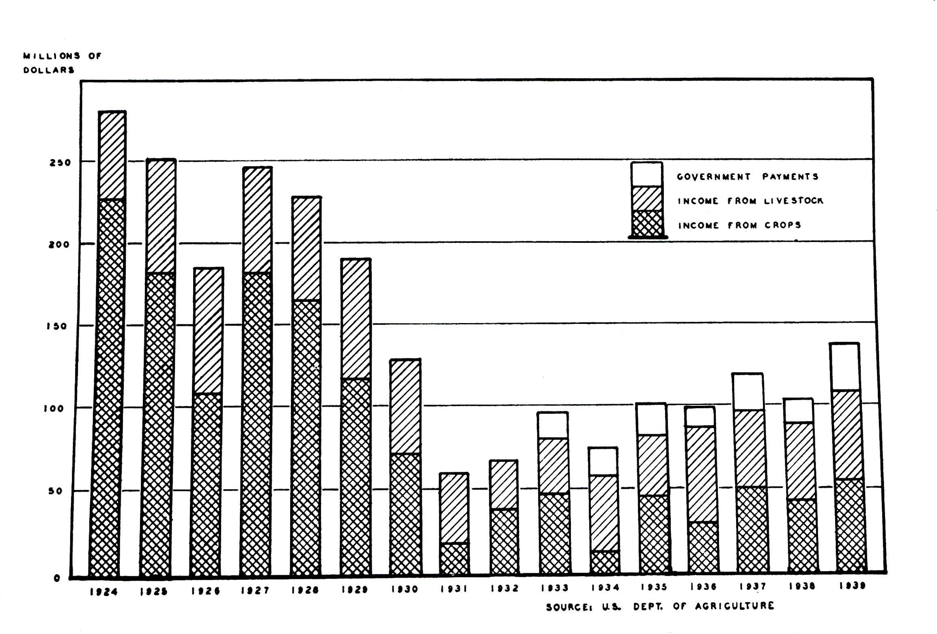Interpretive Note: Because the North Dakota economy was largely dependent upon the products of the farm, agricultural income reflected the economic health of the state. The above graph indicates several things: (1) Farm income continued to drop prior to the onset of national depression in 1930, indicating that agriculture was in economic trouble during the 1920s. (2) In years of severe drought (1931, 1934, and 1936) livestock income significantly surpassed crop income. (3) Farm income gradually rose from 1933 to 1939. (4) Beginning in 1933, government-program assistance accounted for an average of 20 percent of farm income.

New Deal Program Spending in North Dakota, 1933-1939
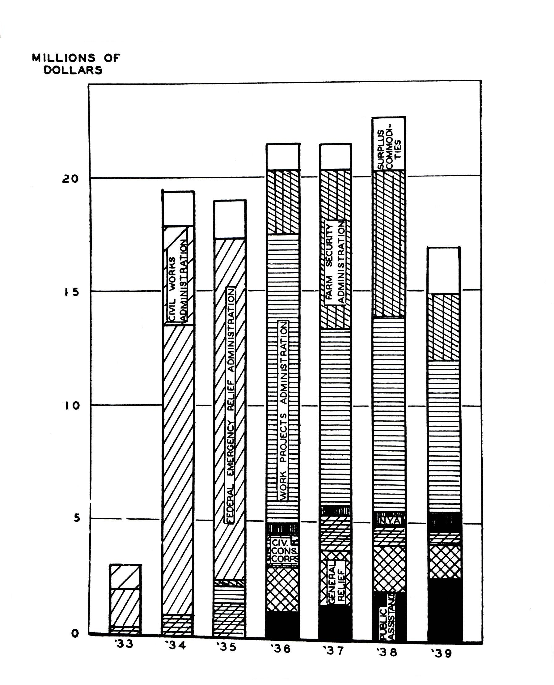
Interpretive Note: The above graph clearly shows the importance of New Deal programs for North Dakota's unemployed people. In all, the federal government expended $266 million in North Dakota. The graph indicates how that money was divided among the New Deal programs.

Population on Relief in North Dakota, 1933-1939
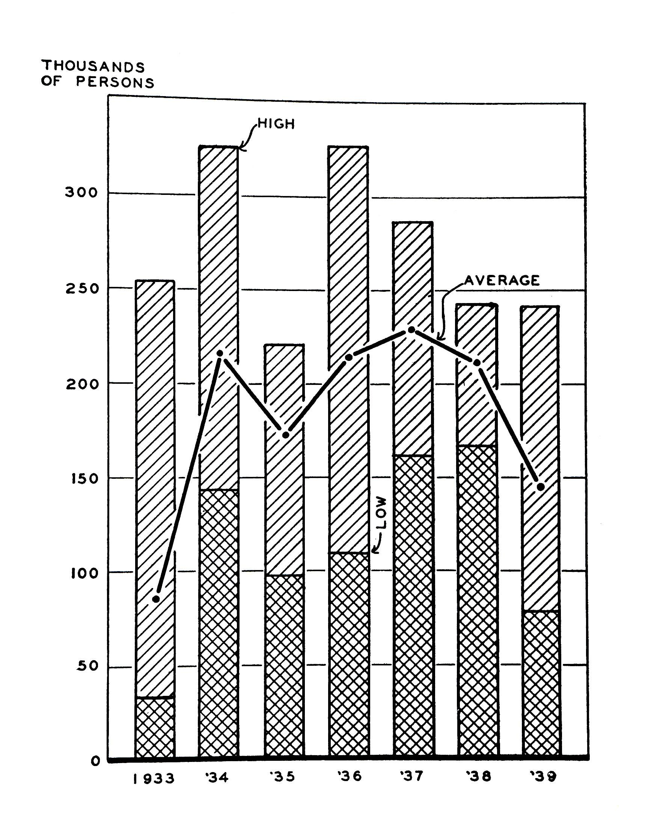
Interpretive Note: Only New Mexico had more people who needed financial or work help than did North Dakota. During the drought years of 1934 and 1936, as high as 65 percent of the population could not have survived without government assistance. The average high of about 230,000 people dropped to just under 150,000 in 1939, indicating that the economy was improving.

The Drought in Context
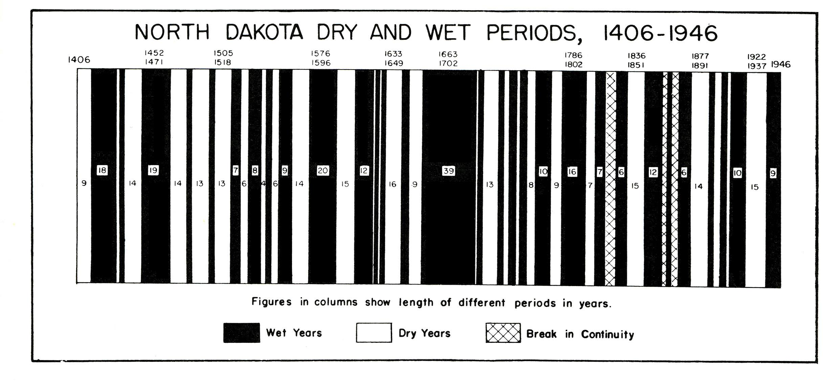Interpretive Note: North Dakota's position in a semi-arid region has resulted in a cycle of wet and dry years. The period between 1922 and 1937 was the longest stretch of dry years since white settlement began after 1870. The drought combined with the depression to make North Dakota most likely the nation's worst-off state.

North Dakota Population: State and Selected Cities
 | 1920 | 1930 | 1940
North Dakota | 646,872 | 680,845 | 641,935
Ashley | 1,009 | 1,033 | 1,345
Bismarck | 7,122 | 11,090 | 15,496
Bottineau | 1,172 | 1,322 | 1,739
Cando | 1,111 | 1,164 | 1,282
Carrington | 1,420 | 1,717 | 1,850
Devils Lake | 5,110 | 5,519 | 6,204
Dickinson | 4,122 | 5,025 | 5,879
Fargo | 21,961 | 28,619 | 32,580
Grafton | 2,512 | 3,136 | 4,070
Grand Forks | 14,010 | 17,112 | 20,228
Jamestown | 6,627 | 8,187 | 8,790
Langdon | 1,228 | 1,221 | 1,546
Mandan | 4,336 | 5,037 | 6,685
Minot | 10,476 | 16,099 | 16,557
Mott | 723 | 1,036 | 1,220
Rugby | 1,424 | 1,512 | 2,215
Stanley | 591 | 936 | 1,058
Valley City | 4,681 | 5,268 | 5,917
Wahpeton | 3,069 | 3,176 | 3,747
Watford City | 260 | 769 | 1,073
Williston | 4,122 | 5,205 | 5,879
Interpretive Note: Although North Dakota's population dropped 38,910 people between 1930 and 1940, almost all towns with a population over 1,000 gained population. Where were the population losers? Almost all towns with between 200 and 600 people lost population. Then, too, an unknown number of farmers gave up, either leaving the state as part of a 60,000-plus out-migration or moving into the larger towns to find employment or live with relatives.

MOST IMPORTANT PEOPLE

F. Halsey Ambrose
Jerry D. Bacon
John Miller Baer
Usher Burdick
Minnie Craig
Lynn J. Frazier
Lorena Hickok
William Langer
Lydia Langer
William Lemke
Thomas Moodie
Rilie Morgan
John Moses

Theodore G. Nelson
Ragnvold Nestos
Gerald P. Nye
Ole Olson
Charles C. Talbott
Arthur C. Townley
Treadwell Twitchell
Henry Von Bank
Bishop Vincent Wehrle
Walter Welford
John Wishek
Fred Wood

MOST IMPORTANT TERMS

Agricultural Adjustment Acts
American Farm Bureau Federation
American Society of Equity
"anti-liars law"
Bank of North Dakota
"Big Biz"
Civil Works Administration
Civilian Conservation Corps
Consumers' United Stores Company
Espionage and Sedition acts
Farm Holiday Association
Farmers Union
Federal Surplus Relief Corporation
Federal Emergency Relief Act
Four Minute Men
House Bill 44
Independent Voters' Association
Indian Reorganization Act

Industrial Commission
Ku Klux Klan
"loyalty issue"
Liberty Loans
National Youth Administration
New Deal
The Nonpartisan Leader
Nonpartisan League
North Dakota Mill and Elevator Assoc.
North Dakota Wheat Growers Association
Nye committee
recall election of 1921
The Red Flame
six-man football
Spanish influenza
WDAY
Works Progress Administration

BOOKS ABOUT THE PERIOD COVERED IN ISSUE FOUR

Bakken, Gordon Morris. Surviving the North Dakota Depression. Pasadena, CA: Wood and Jones, 1992.
This is an especially well-researched and informative book about how a North Dakota community, Northwood and its environs, confronted the Great Depression. The author places what happened in the community in the context of both North Dakota and the nation. Daily life is explained through interviews, newspaper accounts, and the cold facts of state and federal reports. The book offers evidence that the Great Depression "had surprisingly little" impact on the community and refers to the Northwood area as a "pocket of prosperity."
This treatment gives one a good sense of how New Deal programs operated at the local level and how main street and farm reacted to the depression.

Blackorby, Edward C. Prairie Populist, the Life and Times of Usher L. Burdick. Fargo: North Dakota Institute for Regional Studies and Bismarck: State Historical Society of North Dakota, 2001.
In and out of office, Usher L. Burdick was at the center of North Dakota's political activities from the Progressive Era through Nonpartisan League days until his death in 1960. Elected as a progressive reform-minded lieutenant governor in 1910, an unsuccessful anti-Nonpartisan League candidate for governor in 1916, a leader of the Farm Holiday movement in the 1930s, elected to the U.S. House of Representatives in 1934, Burdick's imprint on North Dakota politics was substantial.
This book is more than a biography of Usher Burdick; it is an accurate and exciting analysis of North Dakota's political heritage. The author's diligent research has produced an exceptionally thorough study of one of the state's foremost multi-faceted political figures and at the same time provides a solid chronology of the state's politics.

Blackorby, Edward C. Prairie Rebel, the Public Life of William Lemke. Lincoln, NE: University of Nebraska Press, 1963.
Although this is a biography of William Lemke, it is also a thorough study of North Dakota politics from the Nonpartisan League's glory years (1916-1921) to the immediate post-World War II world. Lemke was the legal brains of the Nonpartisan League and its attorney general. In 1932 he was elected to Congress where he championed the cause of farmers. In 1936 he ran for president on the third party Union ticket. Blackorby's study is based on extensive research, including the invaluable William Lemke papers and countless interviews with important political leaders.
Blackorby concludes that Lemke at heart was a rebel who compiled "a record as one of North Dakota's more distinguished sons." The book enhances one's understanding of North Dakota and its people for those years between 1915 and 1950.

Danbom, David B. Going it Alone, Fargo Grapples with the Great Depression. St. Paul: Minnesota Historical Society Press, 2005.
This is a superb case study of how one city went through the Great Depression of the 1930s and how that depression changed or did not change the community. Based upon widely diverse records ranging from the U.S. Department of Commerce to the Fargo Police Department, the book is much more than the story of federal programs and people in a time of distress. It is more social than economic history. The author lays open Fargo society, dealing with such subjects as juvenile delinquency, illicit liquor traffic, women's work, and the labor movement. He concludes that the Great Depression did not change patterns of life and thinking very much, but, at the same time, "recreating the comfortable past simply was not possible."

Geelan, Agnes. The Dakota Maverick, the Political Life of William Langer. Fargo: Kaye's Printing Company, 1975.
This is the only biography of William Langer who was in the center of North Dakota politics from 1914 until his death in 1959. Although the book is only 150 pages in length, it presents a readable summary of his long career. The author writes from the perspective of one who knew and supported Langer. The reader will come away from this book with a very favorable impression of William Langer but also a better understanding of North Dakota's complicated political world.

Howard, Thomas W. ed. The North Dakota Political Tradition. Ames: The Iowa State University Press, 1981.
Three chapters in this book provide keen insights into North Dakota's politics between 1914 and 1940. Larry Remele's "Power to the People: The Nonpartisan League" is the best brief treatment of the state's most important political movement. He concludes that the NPL modernized state government, allowed access to power by a new group of leaders, and reflected the people's needs and interests.
D. Jerome Tweton's "The Anti-League Movement: The IVA" is the only work that deals with the political faction, the Independent Voters' Association. The IVA, a coalition of Democrats and conservative Republicans, wrested control of the state from the NPL, according to the author, because the NPL went far beyond its original program.
"William Langer and the Art of Personal Politics" by Glenn H. Smith traces Langer's long political career from state's attorney in Morton County (1910) to the governorships (1933-1934 and 1937-1939) and finally the U.S. Senate (1941-1959).

Hudson, Lois Phillips. Reapers of the Dust, A Prairie Chronicle. St. Paul: Minnesota Historical Society Press, 1984.

Most of this autobiographical account deals with childhood during the drought and depression of the 1930s. Based upon her recollections of farm life, Hudson weaves a very readable tapestry of those dust-bowl years on a farm near Cleveland, North Dakota. Like so many North Dakotans, her family gave up trying to eke out a living from the parched earth and moved to near Seattle, Washington. That is where her story ends.

Low, Ann Marie. Dust Bowl Diary. Lincoln: University of Nebraska Press, 1984.
Based upon a diary that the author kept between 1927 and 1937, the book tells the story of the Great Depression on a large stock farm about thirty miles from Jamestown, North Dakota. The author weaves together two themes: the effect of the drought, depression, and government programs on her family, and her coming to maturity in difficult times for her family. (She was born in 1912). Her diary vividly captures the sorrows and joys that accompanied a family's struggle to survive those difficult years. It is a rare glimpse into daily life during the Great Depression.

Morlan, Robert L. Political Prairie Fire, The Nonpartisan League 1915-1922. St. Paul: Minnesota Historical Society Press, 1985.
This is a unique North Dakota storyCthe history of the most successful farmers' movement in American history. The author traces the meteoric rise of the NPL, the brainchild of A.C. Townley, to complete control of North Dakota's government. He discusses in depth the political debate that led to the establishment of state-owned industries, especially the Bank of North Dakota and the State Mill and Elevator.
The book presents a detailed account of the NPL's brief stay in power, its efforts to expand its influence into other farm states, and its rapid decline after the recall of its top elected officials in 1921.
This reprint of the 1955 edition contains an introductory essay by Larry Remele of the State Historical Society of North Dakota. He describes the legacy of the NPL and places that movement within the context of recent research and writing.

Thompson, Era Bell. American Daughter. St. Paul: Minnesota Historical Society Press, 1986.
Originally published in 1946, this autobiography has become a classic. In lively style she writes about growing up in North Dakota as an African-American. Her family moved from Iowa to a small farm near Driscoll in 1914Cshe calls it "God's country." Thompson discusses such topics as bronco busting, social events, relationships with Germans and Norwegian neighbors, school and church activities, and life at the University of North Dakota. She also writes about facing racial prejudice and how growing up in North Dakota influenced her later and very successful life. She left North Dakota in 1931 but never forgot it. This is a delightful look at life in the 1920s.

Tweton, D. Jerome and Daniel F. Rylance. The Years of Despair, North Dakota in The Depression. Grand Forks: Oxcart Press, 1973.

This slender volume presents an overview of the state during the 1930s. D. Jerome Tweton's essay, "The Economic Crisis," discusses the plight of residents as they encountered the worst of economic times. He emphasizes and explains the various New Deal programs, how they operated, and what impact they had on people's lives. Daniel F. Rylance in "The Political Crisis" details the chaos that characterized the politics of the 1930s, concluding that the decade "belonged to William Langer." A fifty-six page photograph section presents "North Dakota and the Depression in Pictures."

Vogel, Robert. Unequal Justice, Bill Langer and His Political Enemies. Mandan: Crain Grosinger Publishing, 2004.
This is the fascinating story of the legal battles that William Langer experienced during his long political career. The author was the son of William Langer's closest advisor and friend and personally knew many of the characters about whom he writes. More importantly, the author was a practicing attorney, a state's attorney, a U.S. attorney, a justice of the North Dakota Supreme Court, and a professor of law. He leads the reader through four Langer trials which stemmed from alleged wrong-doings during his governorships: three conspiracy trials, and one affidavit and perjury trial. A guilty verdict in the first conspiracy trial was reversed. The other three resulted in not guilty outcomes. The author also discusses the investigation and hearing concerning the seating of Langer in the U.S. Senate. The author maintains that the four trials and the senate-seating controversy were instigated by Langer's political enemies. An appendix presents the author's evaluations of how historians have treated Langer.

The WPA Guide to 1930s North Dakota. Bismarck: State Historical Society of North Dakota, 1990.
Originally published in 1938 as North Dakota: A Guide to the Northern Prairie State, as a project of Federal Writers' Project of the Works Progress Administration, this volume presents a cross-section of what the state was like in the 1930s. Subjects covered are agriculture and farm life; industry; racial groups/folkways; schools; churches; transportation; recreation; architecture; press/radio; state parks; playgrounds; and profiles of Bismarck, Fargo, Minot, and Grand Forks. The book also includes ten tours that describe the landscape, economic activities, and towns along each route. An introduction to this edition explains the Writers' Project and evaluates the merits of its work, concluding that the book is a valuable window through which to see North Dakota in the 1930s.

