Teacher’s Guide to the
North Star Dakotan

The North Dakota Studies
Student Newspaper

Issue Two
Territory to Statehood, the Military Frontier,
and Settlement (1861–1889)

by Dr. D. Jerome Tweton, senior consultant
North Dakota Humanities Council
PO Box 2191, Bismarck, ND 58502-2191
701-255-3360 or 1-800-338-6543
www.nd-humanities.org



OBJECTIVES OF ISSUE THREE

1. To explain how the organization of Dakota Territory, the passage of land laws, and the coming of railroads facilitated the growth of northern Dakota.
"Congress Creates Dakota Territory" (p. 1) covers the political structure that was necessary for white settlement to proceed in an orderly way. "Homestead Act Provides Free Land" (p. 1) explains how settlers could obtain land. "Thousands Seek Free Land" (p. 24) discusses the Great Dakota Boom which resulted from the creation of the Territory and free land. "Territorial Political Roundup" (p. 30) presents a few highlights of territorial developments as statehood approached. "Immigrant News" (p. 24) lists fifteen examples of immigrants who came during the Great Dakota Boom. "Railroads Open Dakota for Settlement" (pp. 20-23) discusses the organization and building progress of the two mainline railroads that laid tracks across North Dakota—the Northern Pacific and the Great Northern, and emphasizes their influence on settlement. (Note: Homesteading the immigrant groups is discussed in depth in Issue 4.)

2. To explain why the Dakota Indian people rose up and why the army brought the conflict to northern Dakota.
"Dakota Rise Up in Minnesota" (p. 2) covers the reasons and results of the uprising. "General Sully Claims Victory in His Attack on Village at Whitestone Hill" (p.2 ) and "Killdeer Encampment Attacked'( p.4) traces the role of General Sully's army in the conflict and discusses the results of its campaign in northern Dakota.

3. To discuss how and why the four Indian reservations were created and later reduced in size and what life was like for the Native People.
"Treaties and Reservations" (pp. 5-6) covers federal policy in the creation and maintenance of Fort Berthold, Fort Totten, the Great Sioux, and Turtle Mountain reservations. "Growing Up Dakota" (p. 7), "Life on Fort Berthold Reservation" (p. 8), and "Life Around Fort Totten" (p. 9) present three views of reservation life. "Why So Many Lakota Stay Off the Reservation" (p. 10) presents the views of Colonel Custer and Indian Agent Poole on reservations and explores the question raised in the headline.

4. To demonstrate the role of the United States Army in northern Dakota and what life was like on the isolated military frontier.
"Soldiers Stand Guard Across the Territory" (p. 11) covers the forts and the role of each. "Life at Fort Stevenson" (p. 12) and "Life at Fort Abraham Lincoln About 1874) (p. 13) present the observations of two well-informed participants of the military frontier.

5. To explain the causes and results of the Battle of the Little Big Horn and to discuss the respective roles of the army and the Native People.
"Black Hills Exploration Ends" and "What Did You Find, Colonel Custer" (p. 14) present Custer's Black Hills Expedition of 1874 and the potential for trouble which it raised. "Custer Killed at the Little Big Horn" (p. 14) covers the battle and reaction to it. "Sitting Bull Saw 'Soldiers Falling into Camp' in Vision before Battle" (p. 17), "A Hotly Contested Battle", and "Bloody Knife Killed at Big Horn" (p. 17) present the roles and views of the Native People.

6. To present the factors that brought about the end of the Indian way of life.
"What Happened to the Buffalo" (pp. 18-19) explores the end of the great buffalo herds and its impact on the Native People. "Should Tribal Land be Given Out to Individual Indians" (p. 26) and "New Federal Act Breaks Up Tribal Holdings" (p. 27) discuss the federal effort to end the traditional land holdings of the tribes. "Return of Indian World Promised " (p. 28), "Sitting Bull is Dead" (p. 28), and "200 Lakota Dead at Wounded Knee" (p. 28) cover the final decline of Indian ways and the last conflict between the army and the Native People.
REVIEW QUESTIONS

- Why did President Lincoln appoint Dr. William Jayne as the first territorial governor?
- How did the territorial system work?
- What were the terms of the Homestead Act and the Pre-emption Act?
- Why did the Dakota Indian people rise up in Minnesota?
- Why did General Alfred Sully bring his troops into Dakota Territory?
- What happened at Whitestone Hill?
- Why did General Sully claim a victory at Whitestone Hill?
- Why did General Sully attack the Killdeer Mountain encampment?
- What were the results of the Battle of the Killdeer Mountains?
- How and why was the Fort Berthold Reservation created?
- How and why was the Fort Berthold Reservation reduced in size?
- How does the formation of the Fort Totten Reservation illustrate the policy of removal?
- How and why was the Fort Totten reservation reduced in size?
- What were the terms of treaties negotiated at Fort Laramie in 1851 and 1868?
- What was the great Sioux Reservation?
- How and why was the Great Sioux Reservation broken up into smaller reservations?
- What was the significance of the Black Hills to the Lakota?
- How and why was the Turtle Mountain Reservation created?
- What happened to the land that the Chippewa claimed as theirs?
- What was life on the reservations like?
- According to Frank Bull Bear, what happened on a buffalo hunt?
- What was his school experience?
- What was the school experience of Goodbird?
- What does Goodbird see for the future of his people?
- What was life like for Robert Charbonneau and the Native People at Fort Totten?
- What was Colonel Custer's view of the reservation system?
- How did D.C. Poole characterize the reservation system?
- Why were so many Lakota staying off the reservation?
- For what purpose was each of northern Dakota's forts established?
- How does Colonel de Trobriand describe life at Fort Stevenson?
- What were his attitudes toward Native People and Indian agents?
- According to Libby Custer, what was the role of women at Fort Abraham Lincoln?
- What was daily life at Fort Abraham Lincoln?
- Why did the army explore the Black Hills?
- What was Colonel Custer's assessment of the Black Hills?
- Why were Custer and his troops killed at Little Big Horn?
- What was Sitting Bull's role in the Battle of the Little Big Horn?
- How does She Walks With her Shawl describe the battle?
- Who was Bloody Knife?
- How important was the buffalo to Native People?
- What happened to the great buffalo herds?
- How was the Northern Pacific Railroad organized?
- What parts of northern Dakota did the Northern Pacific open up?
- How was the Great Northern Railroad organized?
- What parts of northern Dakota did the Great Northern open up?
- What impact did the Great Dakota Boom have on settlement?
- What role did bonanza farms play in settlement?
- Who was the Marquis de Morès and what was his vision?
- What people settled northern Dakota Territory during the Great Dakota Boom?
- What were the arguments for and against breaking up tribal lands?
- What were the terms of the General Allotment Act (the Dawes Act)?
- What was the Ghost Dance?
- What was Agent McLaughlin's attitude toward the Ghost Dance and Sitting Bull?
- Why was Sitting Bull killed?
- What happened at Wounded Knee?

DISCUSSION QUESTIONS

- Do you think that North Dakota would have been settled by non-Indian people without the assistance of favorable land laws such as the Homestead Act?
- Do you think that the actions of the Dakota and the army were justified in 1862-1864?
- Had you been in charge of federal policy, how would you have handled relations between whites and the Native People?
- Had you been in Frank Bull Bear's world, would your attitude toward school have been different from his? Why or why not?
- How would you compare and contrast the reservation experiences of Goodbird and Robert Charbonneau?
- Do you think the fort experiences of Trobriand and Libby Custer were typical?
- How would you evaluate Colonel Custer as a military leader?
- How would you evaluate Sitting Bull as leader of the Indian people?
- Who do you think was responsible for the destruction of the great buffalo herds?
- Do you think that non-Indian people would have settled North Dakota had not the railroads opened up the country?
- Has North Dakota gone full circle back to large bonanza-like farms? Why or why not?
- What does the "Immigrant News" tell you about the variety of settlers who came to northern Dakota?
- Evaluate the arguments presented NO and YES on the question of breaking up tribal land holdings. With which side do you agree?
- How do you explain the appeal of the Ghost Dance?
- What connection do you see between the killing of Sitting Bull and the Wounded Knee massacre?
PROJECT SUGGESTIONS

- Assume that you are a newspaper reporter sent along to cover the eventual Battle of the Little Big Horn. Using the interviews and reports, write your story for your readers.
- In essay format compare and contrast the formation and development of the four North Dakota reservations.
- Whether or not to break up the tribal land holdings was a hotly debated issue. Stage a debate on the issue.
- Using a North Dakota highway map (free from the Highway Department), trace General Alfred Sully's pursuit of the Indian people. Note what present-day highways one would take to come as closely as possible to his route.
- Assume that you are a recently arrived immigrant in 1890. Using the railroad map, pinpoint where you would be most likely to homestead and explain your decision.
- Beneath the railroad map are three challenges to the readers of North Star Dakotan. Respond to those challenges.
- If you live or go to school in a town that was founded prior to 1890, prepare a time line for it such as you find on page 32.
- Before land could be sold as lots in a new town, a plat of proposed lots had to be drawn. Below is a sample plat. Draw one for your mythical town, assuming the railroad runs through it.
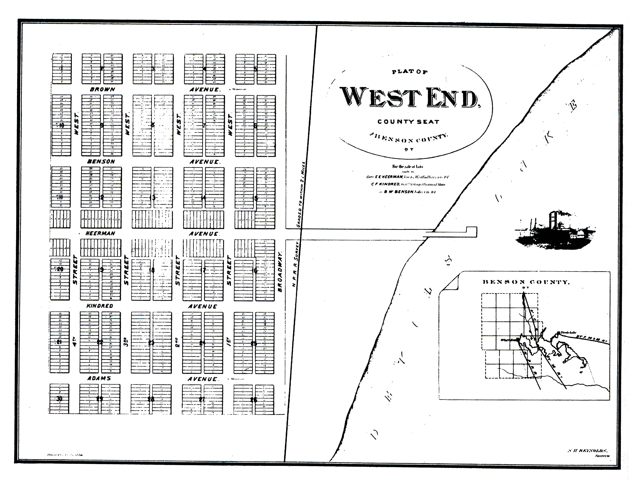

- Assume that South and North Dakota enter the union as one state: Dakota. Prepare a profile of the state of Dakota as to population, political, and economic status. How do you think being one state, rather than two, would have changed the course of history?
- Using the photographs in this issue, prepare an illustrated report supporting the idea that a "picture is worth a thousand words."

QUICK FACTS

White Population: Dakota Territory, Southern and Northern Halves
South (SD) North (ND)
1860 4,837 0
1870 11,776 2,405
1880 98,268 36,909
1890 348,600 (SD) 190,983 (ND)
Interpretive Note:
The rapid growth of southern Dakota accounts for the strength of the statehood movement there. The very large population gain of the 1880 and 1890 census figures reflect the impact of the Great Dakota Boom.

QUICK FACTS

Dakota Territory Political Organization in Maps

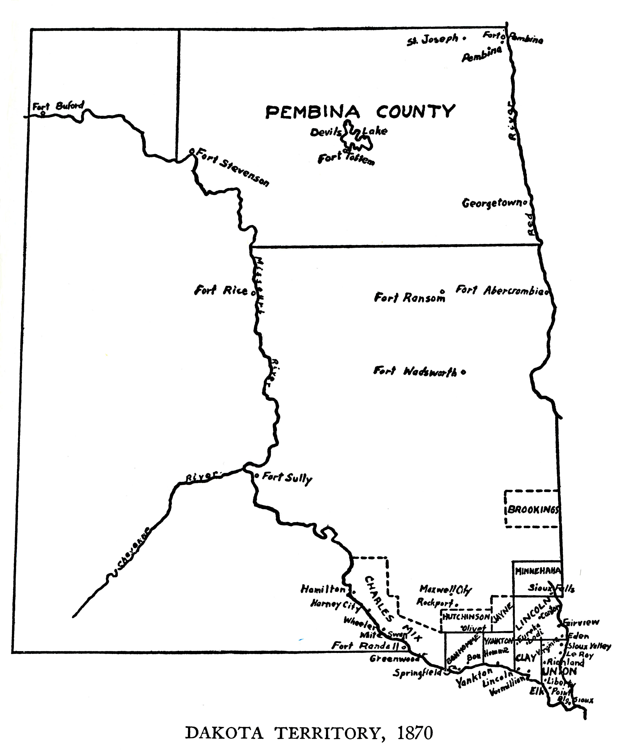
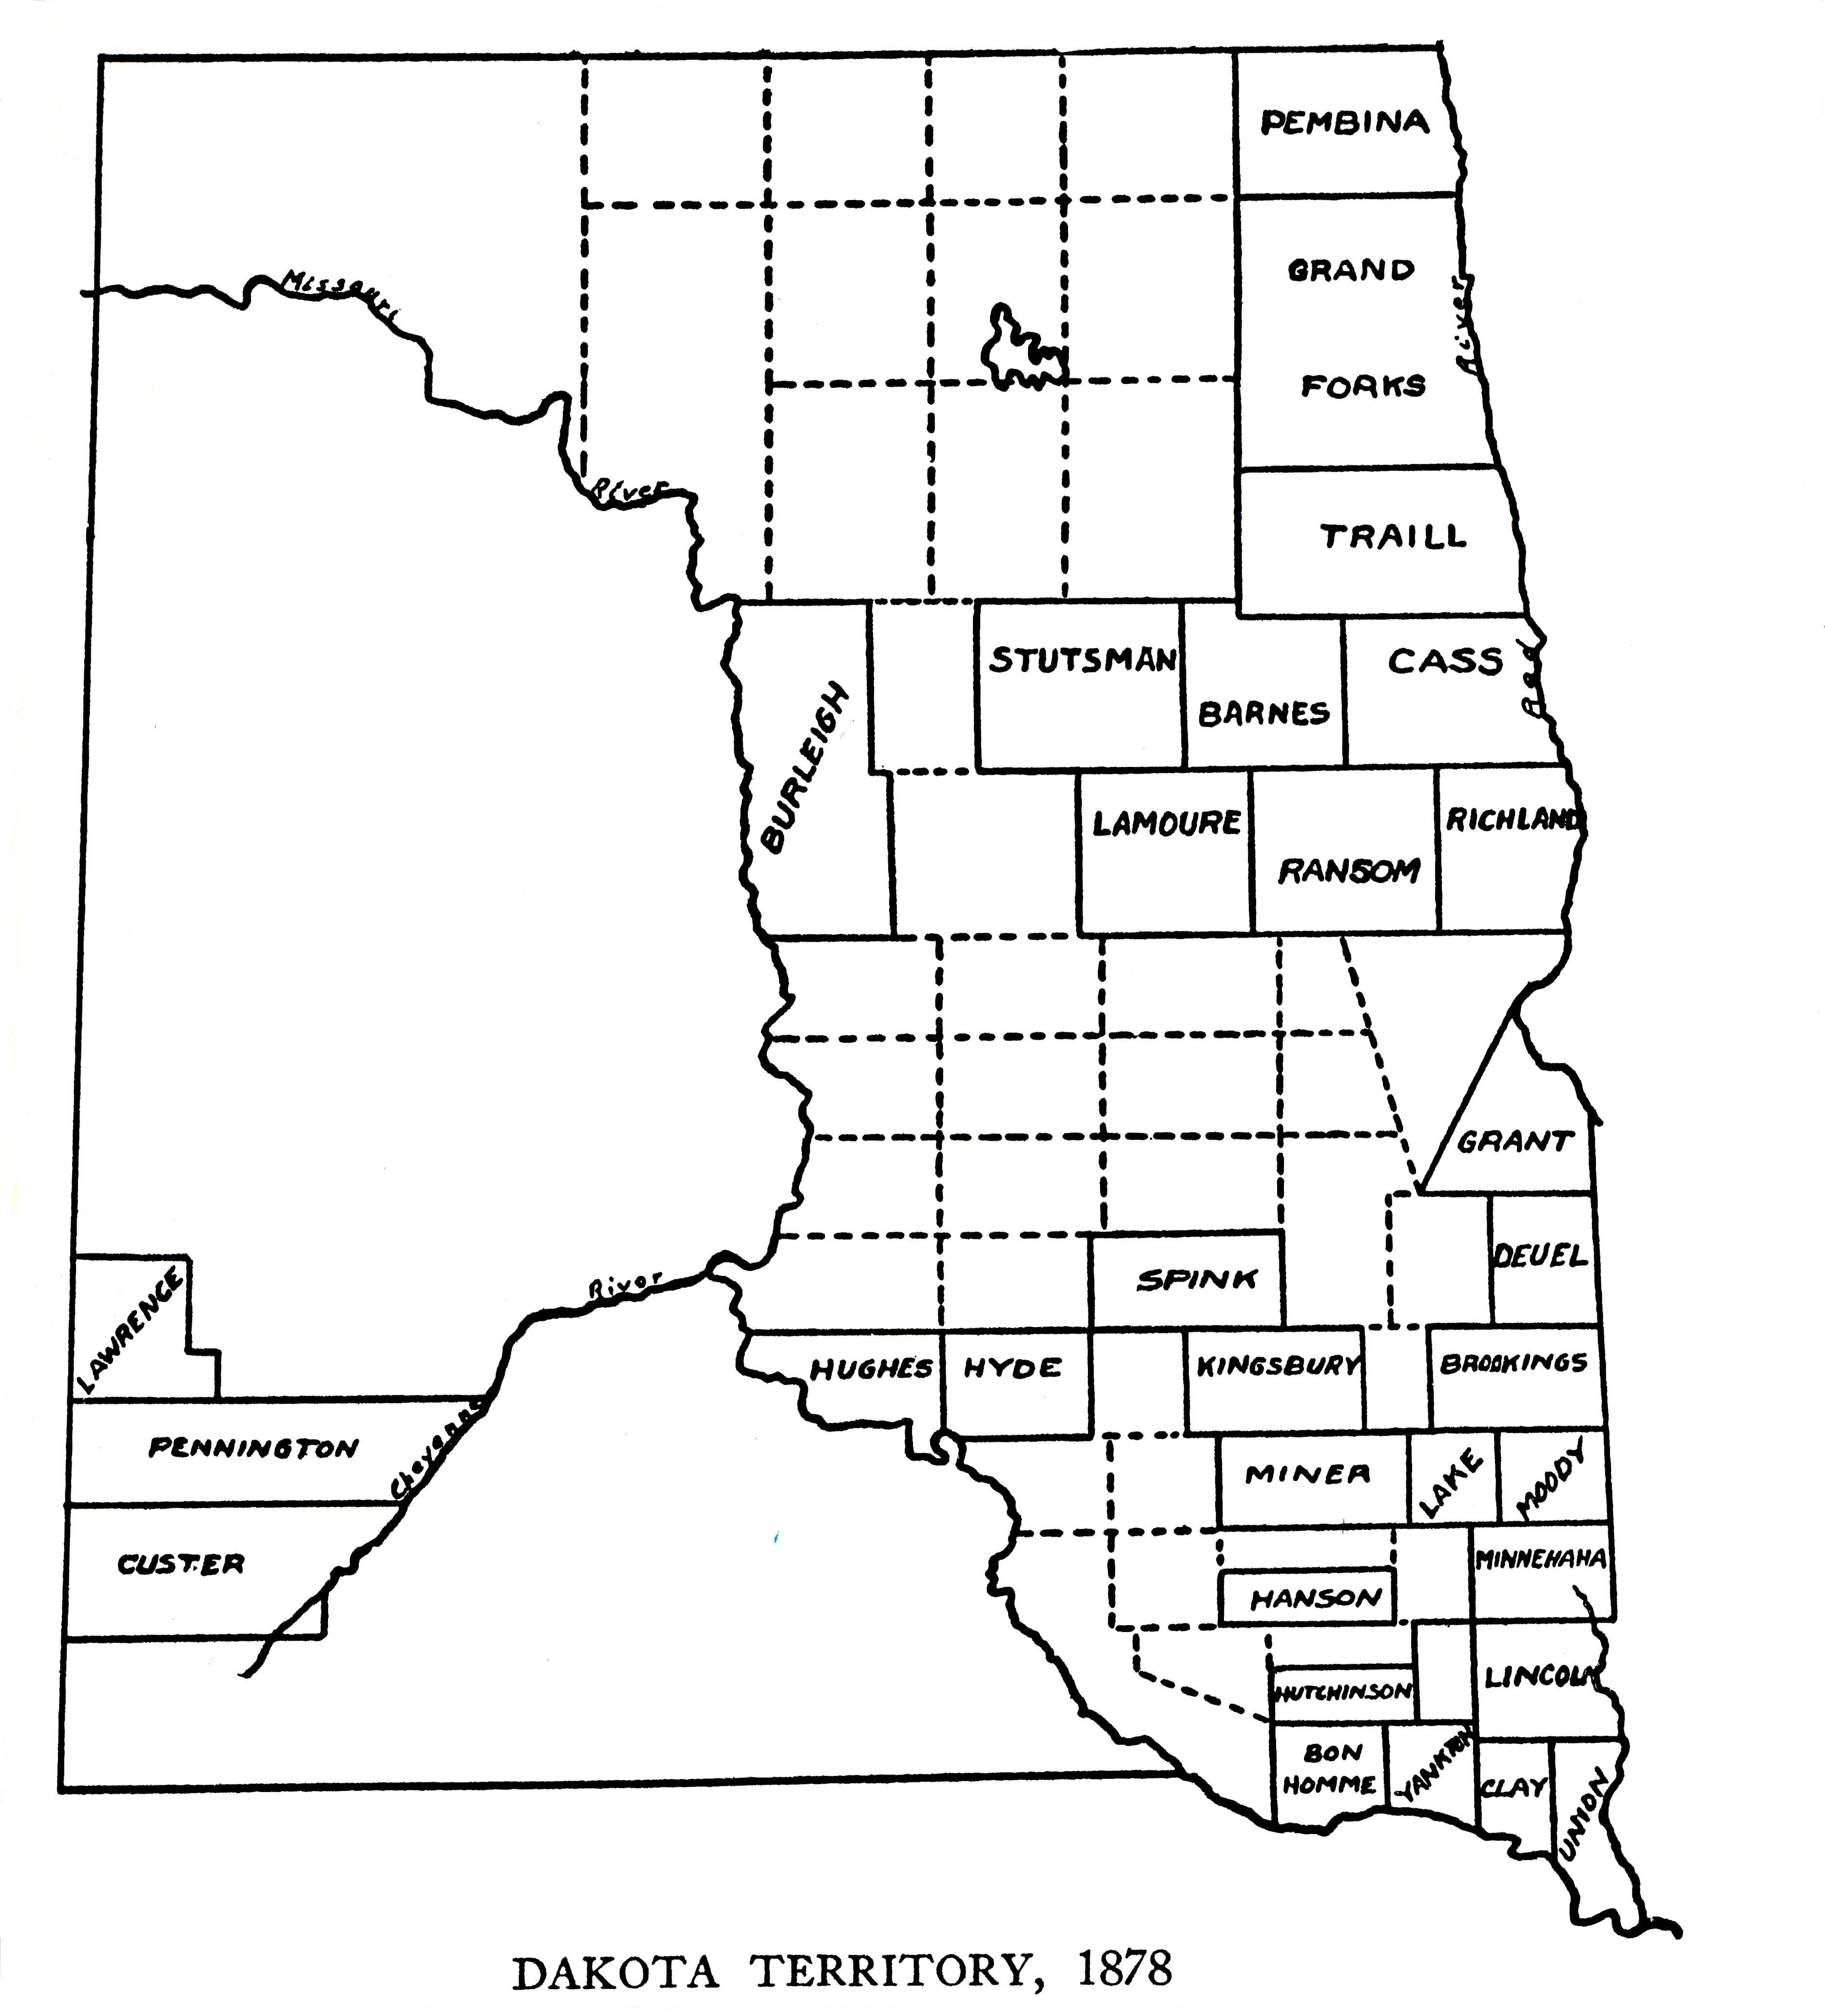

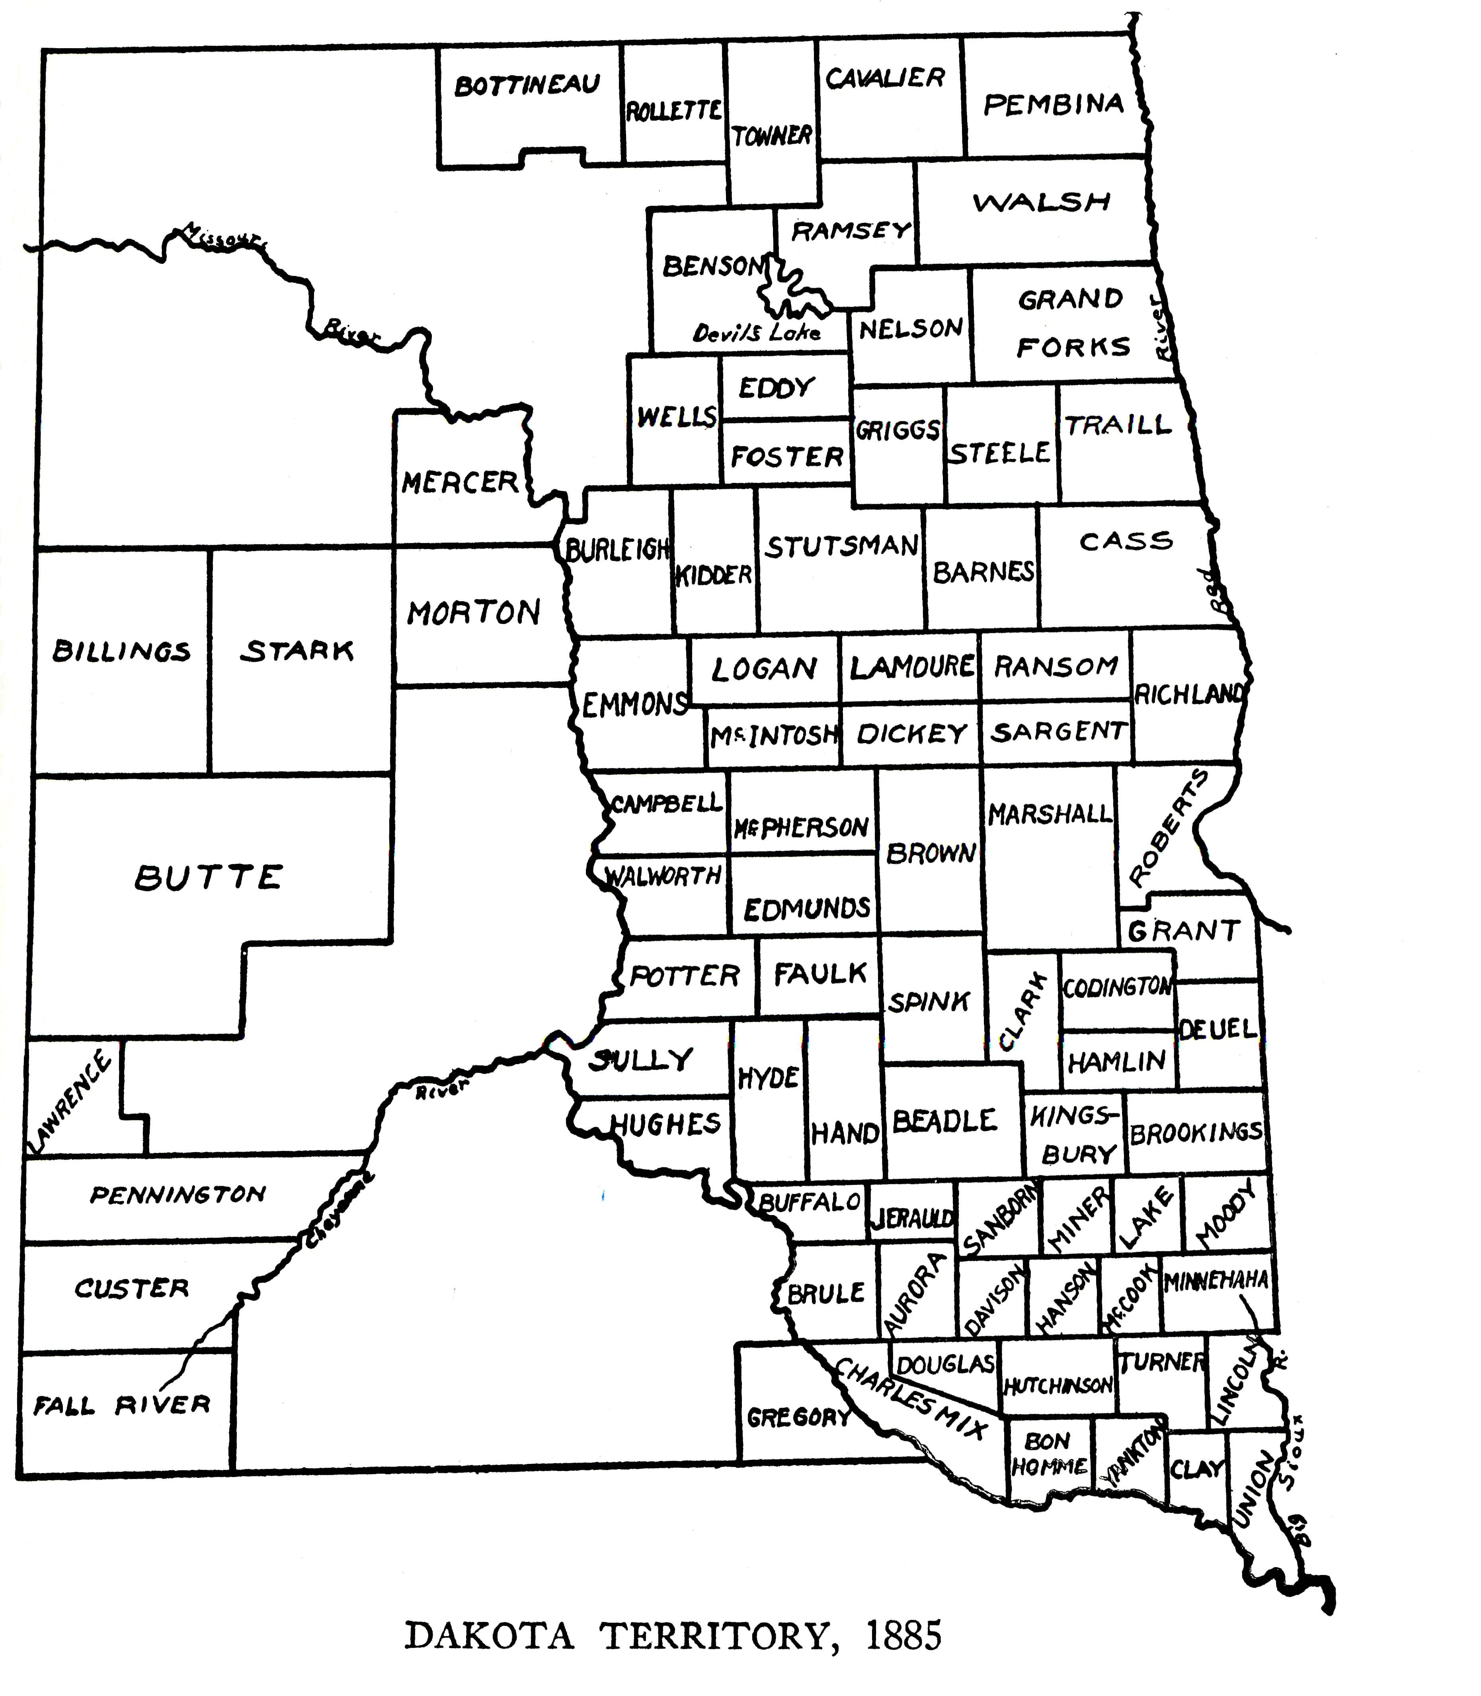

Interpretive Note:
Before the railroad arrived at Fargo in 1871, northern Dakota was organized as one county, Pembina, as indicated on the 1870 map. By 1878, however, the Northern Pacific Railroad connected Fargo in Cass County with Bismarck in Burleigh County, promoting settlement along its route. The Red River's steamboat system allowed settlement to the north of Cass County. By 1885 the Northern Pacific mainline was completed across northern Dakota, and the Great Northern Railroad's mainline was in the process of connecting Grand Forks with Minot. The two railroads built branch lines to counties such as Rolette, Cavalier, LaMoure, and Dickey. The three maps indicate that white settlement almost always followed the rails.

QUICK FACTS

Public Land Taken in Dakota Territory, 1877-1887
Acres
1877 213,000
1878 1,400,000
1879 1,650,000
l880 2,300,000
1881 2,700,000
1882 4,350,000
1883 7,300,000
1884 11,000,000
1885 4,500,000
1886 3,000,000
1887 2,000,000
Interpretive Note:
The period 1882-1885 is the high tide of the Great Dakota Boom. The lion's share of those acres were homesteads in what is today North Dakota.

QUICK FACTS

Railroad Mileage, 1870-1914
1870: 65 miles

1880: 1,225 miles
1890: 1,940 miles
1900: 2,731 miles
1910: 4,201 miles
1914: 5,160 miles
Interpretive Note:
The 1870 figure is for all of Dakota Territory. The significant increase between 1870 and 1890 reflects the great Dakota Boom. The increase between 1900 and 1914 represents the Second Boom. By 1914 North Dakota had 75.88 miles of line per 10,000 people. That ranked only below Montana and Nevada for the most trackage per person. The national average was 25.64.

MOST IMPORTANT PEOPLE

William Jayne
Alfred Sully
George Armstrong Custer
D. C. Poole
Philippe Régis de Trobriand
Elizabeth Bacon Custer
Sitting Bull
Bloody Knife
James McLaughlin
Jay Cooke
Frederick Billings
Kicking Bear
Wowoka
Nehemiah Ordway
James B. Power
Marquis de Morès

James J. Hill

IMPORTANT TERMS TO REMEMBER

Homestead Act
Pre-emption Act
Territorial System
Dakota Uprising
Whitestone Hill Battle
Killdeer Mountains Battle
Treaty of Fort Laramie
Fort Berthold Reservation
Fort Totten Reservation
Great Sioux Reservation
Standing Rock Reservation
Turtle Mountain Reservation
"the chain of military forts"
Black Hills Expedition
Battle of the Little Big Horn
"the Indian's Commissary"
Northern Pacific Railroad
Great Northern Railroad
Chicago and Northwestern Railroad
Soo Line
Great Dakota Boom
Bonanza Farms
"Beef Bonanza"
General Allotment Act (Dawes Act)
Ghost Dance
Wounded Knee
Omnibus Bill

BOOKS ABOUT THE PERIOD COVERED IN ISSUE THREE

Albers, Everett and D. Jerome Tweton. The Way It Was, The North Dakota Frontier Experience Book Three: The Cowboys and Ranchers. Fessenden, ND: The Grass Roots Press, 1999.
This volume contains twelve interviews with cowboys and ranchers who were part of the Dakota west from the 1870s to the turn of the century. The interviews, originally conducted by the WPA during the late 1930s and early 1940s, represent the broad spectrum of ranch activity. The emphasis is on everyday life. Of special interest are Margaret Roberts's memories of Theodore Roosevelt. Introductory essays place the interviews in historical context. The book is illustrated.

Anderson, Gary Clayton. Little Crow, Spokesman for the Sioux. St. Paul: Minnesota Historical Society Press, 1986.
This is a biography of Little Crow who became the forceful leader of the Dakota (Santee) in Minnesota. He and his people were forced into a policy of accommodation with the federal government and exchanged title to their homeland for cash annuities, food, and government assistance such as schools and farm know-how.
When the government failed to live up to the agreements and fearing loss of their identity, the Dakota turned to Little Crow to lead them in a war of preservation; thus, the uprising of 1862 eventually spread to Dakota Territory. The strength of the biography rests in its explanation of the conflict that led to the bloodshed at Whitestone Hill and in the Killdeer Mountains of North Dakota.

Barnett, Louise. Touched by Fire, the Life, Death, and Mythic Afterlife of George Armstrong Custer. New York: Henry Holt, 1996.
This 500-page volume emphasizes Custer's Great Plains military experience with more than hundred pages dedicated to his Dakota experience. She concludes that his defeat at Little Big Horn was due to his belief that he and his men, as had been true in the past, could handle any number of Indians. Of special interest the author concludes the book with Custer's "afterlife." During her long widowhood (she died in 1933), Libby Custer kept her husband's name alive and worked to enhance his reputation as a military genius.

Branch, E. Douglas. The Hunting of the Buffalo. Lincoln: University of Nebraska Press, 1997.
First published in 1929, the book advanced the thesis that the demise of the buffalo presented a key to understanding the end of the western frontier. The book traces the gradual, then rapid, decline of the great buffalo herds of the eighteenth and nineteenth centuries. The author discusses the role of the buffalo in Indian culture and the white sport business of buffalo hunting. There is a special chapter on North Dakota's Red River Valley and two chapters on the westward movement of buffalo hunting across North Dakota into the Yellowstone Valley.

Custer, Elizabeth B. Boots and Saddles. Norman: University of Oklahoma Press, 1961.
Subtitled Life in Dakota with General Custer and originally published in 1885, this is an autobiographic account of the Custers' years at Fort Abraham Lincoln from 1873 through 1876. She wrote Boots and Saddles to provide civilians with a glimpse of garrison and camp life—what daily life was like on a frontier military post—and to remind the public that her husband was an outstanding person and capable military leader.
She deals with a variety of everyday matters including blizzards, amusements, food preparation, gardening, religious services, maids, and ice harvesting. At the same time the career of her husband is primary: his writings and library, the Black Hills Expedition, and relations with Indians, especially Two Bears and Rain in the Face.

Dick, Everett. The Sod-House Frontier 1884-1890. Lincoln: Johnson Publishing, 1975.
Based on reminiscences, diaries, letters, and newspapers, this book is a social history of Kansas, Nebraska, and Dakota. He covers topics such as the sod house, homesteading, raising crops and cattle, white-Indian relations, life on the farm, sports, food, political activity, the church, prairie towns, main streets, doctors, and customs.
This is integrated history. That is, when the author covers a specific topic he draws on a the experiences of the entire region , not just one place. So when he discusses homesteading, he uses examples from Kansas, Dakota, and Nebraska. Every day life emerges as the main theme of the book. Many photographs illustrate daily life.

Drache, Hiram M. The Day of the Bonanza, A History of Bonanza Farming in the Red River Valley of the North. Danville, IL: The Interstate Printers and Publishers, Inc., 1969.
This is the only work that fully explains the rise and decline of the huge farms that thrived in the 1870s and 1880s. The first half of the book discusses in general terms the organization and operation of the bonanza farms. The second half zeros in on one farm: the Amenia and Sharon Land Company. The author traces the formation, operation, and decline of the farm in great detail, providing an in depth view of a bonanza farm and its influence on the development of agriculture. A 36-page photograph portfolio presents dozens of pictures that illustrate the day of the bonanza.

Hagedorn, Herman. Roosevelt in the Badlands. Medora: Theodore Roosevelt Nature and History Assn., 1987.
Originally published in 1921 (just two years after Theodore Roosevelt's death), this stands as a classic story of his time in the Dakota Badlands during the mid-1880s. In putting together the story, the author had the golden opportunity of interviewing dozens of the people who lived and worked with Roosevelt; the result is an anecdote-filled history that emphasizes Roosevelt's adventurous life in the West. The author takes Roosevelt from buffalo hunting and ranch organizing in 1883 to the wipe-out blizzards of 1886-l887.

Heidenreich-Barber, Virginia, ed. Aristocracy on the Western Frontier, The Legacy of the Marquis de Morés. Bismarck: State Historical Society of North Dakota, 1994.

Two of the three articles in this publication deal with the Marquis' life and business in the Badlands of Dakota during the 1880s. D. Jerome Tweton in "The Marquis de Morés in the Badlands of Dakota" discusses Morés' various business schemes which he centered in his town of Medora. His meatpacking enterprise which stretched as far as New York City was at the heart of his operations.
Frank E. Vyzralek in "The Marquis de Mores—Riley Luffsey Murder Case, 1883-1885" covers the legal problems that the Marquis faced when Luffsey was killed in a wild shootout that involved several men, including the Marquis.

Jackson, Donald. Custer's Gold, The United States Cavalry Expedition of 1874. Lincoln: University of Nebraska Press, 1972.
This book accomplishes two main objectives. One, to examine the Black Hills as part of the struggle between whites and Indians for continent. Two, to portray in detail the workings of an army expedition: the routines of camp life. The author concludes that the discovery of gold in the sacred Black Hills ignited tensions that ultimately led to conflict at the Little Big Horn. Of special significance, appendices include the full texts of the Fort Laramie Treaty of 1868 and the 1876 revised agreement that ceded additional territory, including the Black Hills, to the U.S. government.

Lamar, Howard Roberts. Dakota Territory, 1861-1889. Fargo: North Dakota Institute of Regional Studies, 1998.
After explaining the history and nature of the territorial system, the book offers a detailed account of the political development of Dakota Territory. The author presents frontier politics as a stormy business in which legislatures were rowdy, elections disputed, corruption not infrequent, and patronage coveted.
The author focuses on two significant developments: the organization and strength of the Republican party and the statehood movement. Between 1877 and 1889 the statehood enthusiasts made several attempts to achieve some form of statehood, either one state of Dakota or two states as exist today. Of special interest is the coverage given to Alexander McKenzie, the future political boss of North Dakota, in territorial politics.
The concluding chapter is devoted to the role and influence of farmers in the political process during the years just prior to statehood in 1889.

Libby, Orin G. The Arikara Narrative of Custer's Campaign and the Battle of the Little Big Horn. Norman: University of Oklahoma Press, 1998.
Several Arikara served as scouts for Custer in the days leading up to the Battle of the Little Big Horn. Orin G. Libby was an early advocate of oral history and in 1912 oversaw the interviewing of the nine surviving Arikara scouts of the Little Big Horn.
These interviews, conducted at Fort Berthold, present an Indian first-hand view of those 1876 events. "The present volume," Libby concluded in 1920, "is offered as a piece of evidence worth of being included in the source material for the future study of the period of our history."

Martin, Albro. James J. Hill and the Opening of the Northwest. St. Paul: Minnesota Historical Society Press, 1991.
This lengthy (676 pp) biography presents a detailed account of the man who organized the Great Northern Railroad and built it across northern North Dakota, thus opening the area to white settlement. Emphasis is placed upon the complicated story of the railroad's formation and its expansion to become the nations' most northerly transcontinental road. of special interest to North Dakota history is Chapter 3, "Northward the Course of Empire" which discusses Hill's involvement in opening up the Red River Valley through the development of steamboating and Chapter 12 "On to Montana" which treats the laying of tracks from Grand Forks to Williston. Throughout, the author depicts Hill as one who had great interest in North Dakota's economic progress.

McLaughlin, James. My Friend the Indian. Lincoln: University of Nebraska Press, 1989.
Originally published in 1910, this autobiography focuses on his many years as an Indian agent on the Fort Totten and Standing Rock Reservations. He saw himself as a friend and defender of the Native People. From his unique position, he presents his views on topics such as life with agency Indians, Sitting Bull and his death, the Battle of the Little Big Horn, how the Indian gets a name, and treaty making and breaking.
McLaughlin argues that the reservation system had a demoralizing effect on Indians. He called for the end of annuities and the release of federally held funds that rightfully belonged to the people. Then, he is sure, nine out of ten Indians would succeed in life.

Meyer, Roy W. History of the Santee Sioux. Lincoln: University of Nebraska Press, 1993.
This is a comprehensive history of the Dakota from the first encounter with Europeans through the twentieth century. Of special importance for this issue are chapters 10 and 11 which discuss the "Upper Sioux," the Sisseton and Wahpeton who became part of Dakota Territory's history. Chapter 10 deals with the formation of and life on the Sisseton Reservation. Chapter 11 is devoted to the organization of and developments in what would be called the Fort Totten Reservation. The author views allotment as a tragic failure and farming as a contrary way of life.

Monaghan, Jay. Custer, The Life of General George Armstrong Custer. Lincoln: University of Nebraska Press, 1971.
Since it was originally published in 1969, this has been the standard treatment of Custer's life. Like most works on Custer the emphasis is on his military career—he was a life-long soldier. After three preliminary chapters on his early life, the book presents in vivid detail in chapters 4 through 18 the Civil War years, concluding that Custer as a brilliant tactician. Chapters 19 through 25 present Custer's career as an "Indian fighter" on the southern Plains. The book's last three chapters focus on the Fort Abraham Lincoln years and the Battle of the Little Big Horn where, according to the author, Custer exercised poor judgment as a military leader.

Morris, Edmund. The Rise of Theodore Roosevelt. New York: Ballantine Books, 1979.
Four chapters in this Pulitzer Prize-winning biography of Theodore Roosevelt deal in a clear way with his northern Dakota, Badlands ranching experience. The author concludes that Roosevelt regained his confidence and mental health in the Dakota wilderness, but that at heart, although he looked at himself as a man of the West, he was an urbanite who could not miss the excitement of eastern and national politics. The author relates the traditional Roosevelt ranch story but weaves in new material in an interesting manner.

Pfaller, Louis L. James McLaughlin, The Man with an Indian Heart. Richardton, ND: Assumption Abbey Press, 1978.
This is an in-depth look at the life and work of an Indian agent who played key roles on two Dakota reservations. McLaughlin worked for the Indian service from 1871 to 1923. The author labels his record as one of "exceptional excellence" and "the most competent negotiator." In sum, the author concludes: "He loved the Indians."
He deals at length with McLaughlin's role in easing tensions as the agent at Fort Totten, 1876-1881. His work on the Standing Rock Reservation, 1881-1895, receives the most attention. McLaughlin's position as a "civilizing agent," his relations with Sitting Bull, and his role in the Ghost Dance and its aftermath are treated in depth. His involvement in many land and boundary disputes and his work as an inspector round out the biography.

Robinson, Elwyn B. History of North Dakota. Lincoln: University of Nebraska Press, 1966; reprint, North Dakota Institute for Regional Studies, NDSU, 1995.
Four chapters in this general history of North Dakota are appropriate to this issue. Chapter 6, "The Beginnings of Settlement," covers steamboating on the Red River, the building of the Northern Pacific Railroad, and the organization of the earliest towns. Chapter 7, "The Great Dakota Boom," traces the influx of white settlers and town building down to 1890. Discussion also centers on the expansion of railroads, the Minneapolis market, bonanza farms, and the taking up of land. Chapter 8, "Pioneer Life," explains what life was like for the early settlers. Chapter 9, "The Opening of the Missouri Plateau," covers the military, reservation life, the demise of the buffalo, and the ranching/farming frontier.

Utley, Robert M. Cavalier in Buckskin, George Armstrong Custer and the Western Military Frontier. Norman: University of Oklahoma Press, 1988.
This is not a full-blown biography of Custer; it is a factual and interpretive study of his role as frontier military leader. It places Custer in the context of the westward movement of white settlement; it is a blend of the man and his times. The first half of the book covers Custer's career on the southern Great Plains and the development of his reputation as "an Indian fighter." The second half deals with Custer's years at Fort Abraham Lincoln. Special attention is paid to the Black Hills Expedition of 1874 and the results of that foray into sacred Lakota territory and, of course, to the Battle of the Little Big Horn.
The author analyzes the reasons for Custer's defeat, concluding that the simplest answer is that the army lost because the Indians won: "Perhaps no strategy or tactics could have prevailed against Sitting Bull's power." Twenty-four pages of photographs and eight maps help explain Custer and the military frontier.

Utley, Robert M. The Last Days of the Sioux Nation. New Haven: Yale University Press, 1963.
The book focuses on the rise of the Ghost Dance and the conflict which culminated at Wounded Knee. The author provides a clear picture of Lakota life before and after the reservation system was established, and how the life that the government imposed upon them ran counter to their needs. The author concludes that the Lakota reaction to the newly imposed reservation system eventually led to the conflict between the Indian people and the army at Wounded Knee.

Utley, Robert M. The Lance and the Shield, the Life of Sitting Bull. New York: Henry Holt, 1993.
This newer biography of Sitting Bull relies heavily upon the work done by Walter Campbell in his 1932 biography. But he has gone further and as an historian has emphasized the historic forces at work in Sitting Bull's life. More attention is paid to historical context. Yet, the final conclusion is much the same: "He [Sitting Bull] was a real Indian, and a real person, completely faithful to his culture. He earned greatness as a Hunkpapa patriot, steadfastly true to the values and principles and institutions that guided his tribe."

Vestal, Stanley (Campbell, Walter). Sitting Bull, Champion of the Sioux. Norman: University of Oklahoma, 1932 and 1957.
First published in 1932, this remains the authoritative classic on the life of the Hunkpapa Lakota spiritual leader. In putting together this account of what Vestal believed to be the greatest of the Plains Indians, he went far beyond dependence on government and missionary records. In 1928, 1929, and 1930 Campbell spent his time in the field, interviewing countless native people who knew Sitting Bull. This is the great strength of this biography.
The book is a rare glimpse at the great leader's world. Within the context of a full biography, the author covers the military invasion of 1862-1864, Custer's Last Stand, the Ghost Dance, and the eventual killing of Sitting Bull. The author concludes that Sitting Bull "was the very heart and soul of the frontier."

Wilson, Gilbert. Goodbird the Indian, His Story. St. Paul: Minnesota Historical Society Press, 1985; Waheenee, An Indian Girl's Story. Lincoln: University of Nebraska Press, 1981; Buffalo Bird Woman's Garden. St. Paul: Minnesota Historical Society Press, 1983.
Gilbert Wilson was an amateur anthropologist (he later earned a doctorate in anthropology) and Presbyterian minister from Mandan who early in the century began to study and interview Hidatsa people, especially the family of Goodbird and his mother, Waheenee. The relationships became so close that the Hidatsa family adopted Wilson into their Prairie Chicken Clan. He took his interviews and turned them into books for young people, Goodbird in 1914 and Waheenee in 1921.
Together the two books present a look at life on the Fort Berthold Reservation. Waheenee's story is especially noteworthy for her descriptions of family life, gardening, and symbolism. In Goodbird's the chapters on farming, schooling, and adjustment to white ways present unique pictures of one Hidatsa's life. Buffalo Bird Woman's Garden is Waheenee's description and meaning of Hidatsa agriculture. She describes the process from seed preparation through harvest. She includes the songs, ceremonies, and stories that are requirements for a bountiful harvest. These three books provide a sound and useful look at Hidatsa ways.

Woodward, Mary Dodge. The Checkered Years. St. Paul: Minnesota Historical Society Press, 1989.
Originally published in 1937, this is the diary of a woman who lived on a bonanza farm near Fargo, 1884-1888, during the heyday of those huge operations. For five years she recorded the agricultural activities as well as the terrible blizzard of 1888, her relationships with her family, her frustrations with gardening and chicken raising, and mirages on the prairie.
Her focus on the domestic, her profile of seasonal household patterns, provides a unique view of life in the Red River Valley. An introduction by historian Elizabeth Jameson places Woodward and her life work in historical perspective.

