Unit 3 – Lesson 2 – Topic 7

TOPIC 7 – URBAN LIFE

Topic Overview
Topic 7 highlights urban life in North Dakota and includes primary sources that will help you understand how towns and cities came to be established in the state and the interdependence of agriculture and urban centers.

Topic Objectives
- As a result of the study of Topic 7, you will be able to
  - Analyze and interpret primary documents.
  - Understand how and why towns and cities were established in North Dakota.
  - Recognize the interdependence of agriculture and urban centers.

ND Content Standards
- 8.1.2
- 8.2.11
- 8.5.3

Common Core Standards
- RH 2
- RH 5
- WHST 2

Topic Activities
- Organizing Data
- Debate/Discussion

Unit 3 – Lesson 2 – Topic 7

Organizing Data

Fargo has been North Dakota’s largest city since the 1880s. In the flow chart below, sequence the growth of Fargo with key facts from your reading of Section 2. Complete as many boxes as you can.
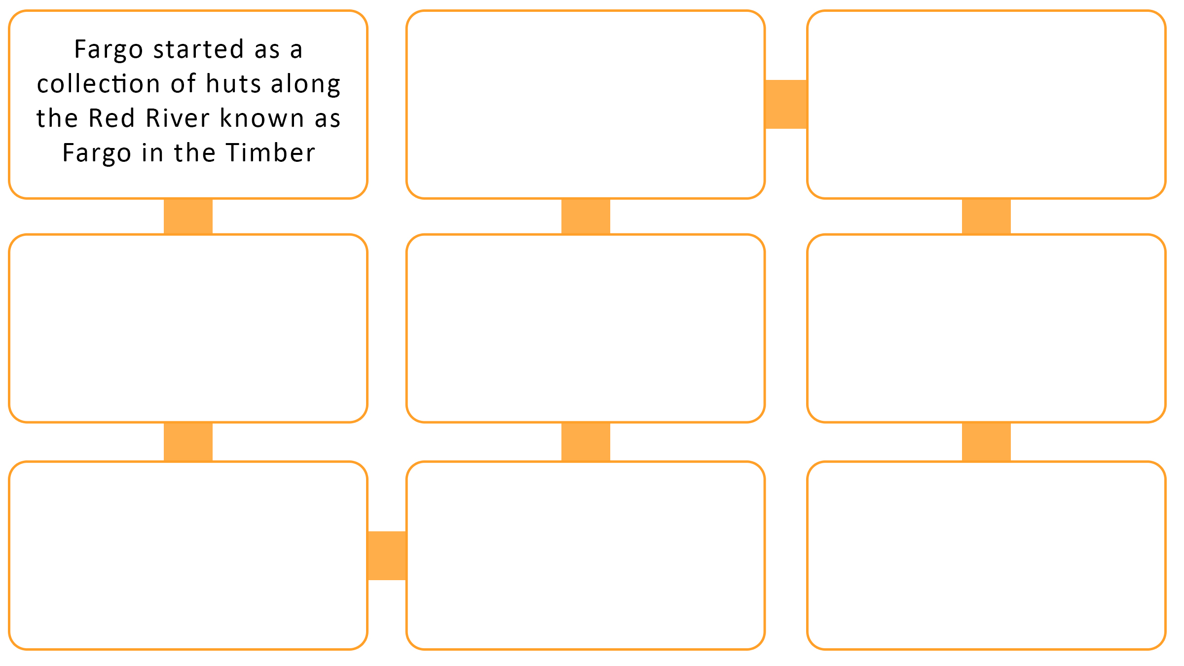

Unit 3 – Lesson 2 – Topic 7
Debate/Discussion

From your reading about how towns and cities were established and grew when settlers came to Dakota Territory/North Dakota to farm, write down and then discuss several reasons why agriculture and urban growth depended on each other for their survival and success.

