Unit 3 – Lesson 1 – Topic 3

TOPIC 3 – DEVILS LAKE

Topic Overview
Topic 3 highlights the steamboat era on Devils Lake. It includes primary sources that will help you understand the importance of steamboat travel on the early growth and development of the Devils Lake area.

Topic Objectives
- As a result of the study of Topic 3, you will be able to
  - Analyze and interpret primary documents.
  - Interpret maps to identify past and current water levels of Devils Lake.
  - Discuss effects of the changing water levels of Devils Lake throughout history.

ND Content Standards
- 8.1.1
- 8.1.2
- 8.3.4
- 8.5.3

Common Core Standards
- RH 2
- RH 7
- WHST 2

Topic Activities
- Learning from Historical Documents
- Reading a Map

Unit 3 – Lesson 1 – Topic 3
Learning from Historical Documents

To access a photo/document/map, refer to the topic reading assignment or use the SEARCH feature to enter its name or number.

Read about the Minnie H, and examine the following historic photographs to gain additional information about the Minnie H. Answer the questions and complete the chart below.

- 2010-P-010-02. The Minnie H carried freight and passengers around Devils Lake for 26 years. She was built at Devils Lake by E. E. Heerman.
- 2010-P-010-073. E. E. Heerman was a steamboat captain with a vision for operating a steamboat on Devils Lake as his career on the Mississippi River came to an end. He built the Minnie H at Devils Lake in 1882.
- 2010-P-010-040. This group is enjoying a pleasant day on Graham’s Island on Devils Lake. They were able to travel to Graham’s Island on the Minnie H or another ferry boat. Devils Lake became a local tourist destination because of its beautiful scenery, excellent fishing, and steamboat transportation.
- 2012-P-024-0001. Greenwood farm is an example of the prosperous farms that were established near Devils Lake. The lake combined with the fine soil quality brought prosperity to the region.
- 0096-083. As Devils Lake waters fell, fishing and use of the steamboats ceased. This pole shows how far the lake waters dropped from 1870 to about a1920.
Answer the following questions:

- What influences did E. E. Herman have on the early growth and changes in the Devils Lake Area?

- How did the Minnie H affect the lives of the people in the Devils Lake area?

- How did the steamboat affect the economy and the population in the Devils Lake area?

- Identify challenges in the physical landscape of the Devils Lake area for the early settlers and for modern day economic development.

Unit 3 – Lesson 1 – Topic 3

Learning from Historical Documents (continued)

Minnie H and Its Impact On Devils Lake

Influences of E. E. Heerman

Minnie H Impact on People in Devils Lake

Effect on Economy and Population

Challenges of Physical Landscape of Devils Lake to Early Settlers

Unit 3 – Lesson 1 – Topic 3
Reading a Map

To access a photo/document/map, refer to the topic reading assignment or use the SEARCH feature to enter its name or number.

Study the U.S. Geological Survey (USGS) map in cooperation with the North Dakota Water Commission found at http://nd.water.usgs.gov/devilslake/data/dlelevation.html, the Devils Lake at Various Elevations map, and the DH0096-083 photo showing a pole in Devils Lake to indicate how much the lake waters dropped from 1870 to around 1920. What are your observations for each? Write down your observations for each document in the appropriate circle.

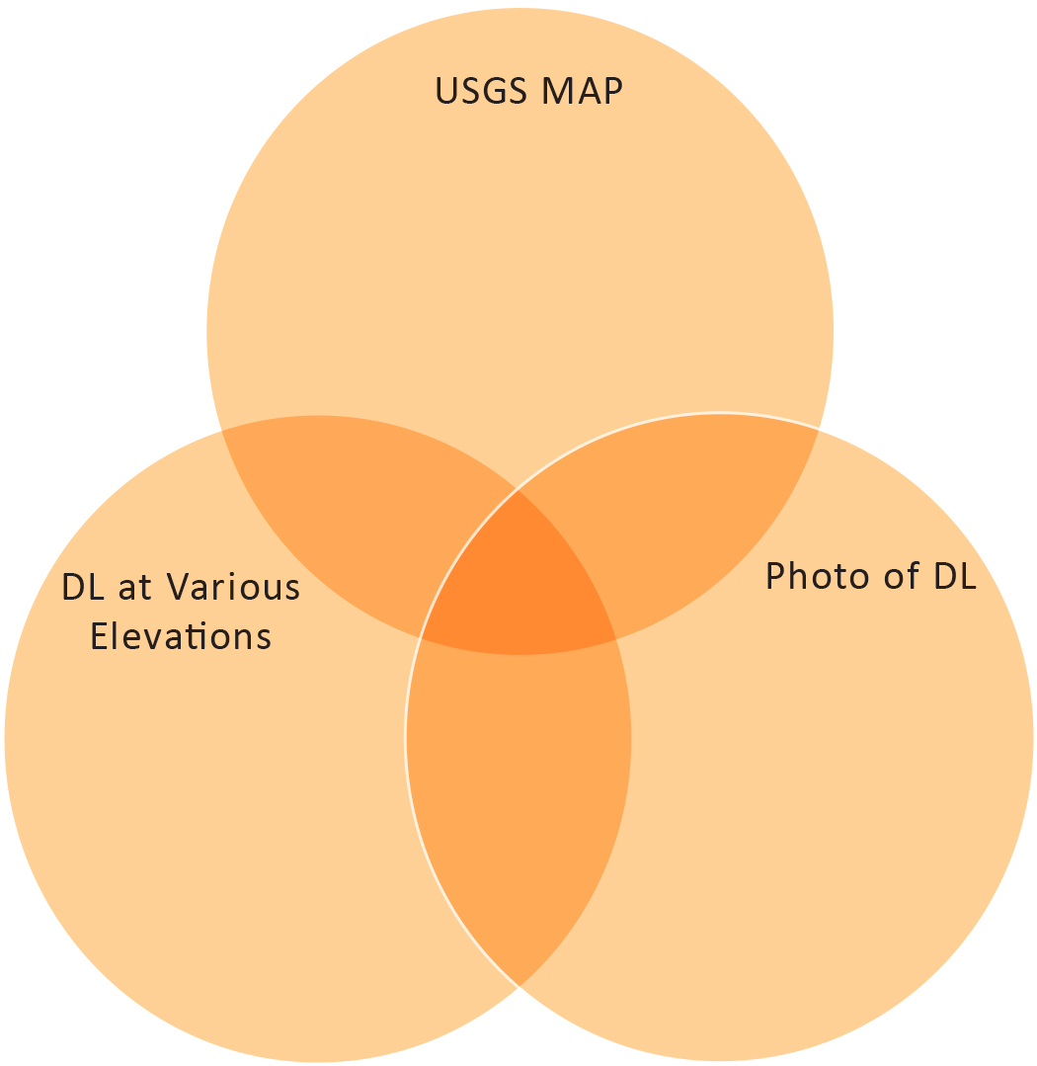

After studying these three primary source documents relating to Devils Lake, what are your conclusions?

