Unit 1 – Lesson 1 – Topic 2

TOPIC 2 – GEOLOGY

Topic Overview
Topic 2 highlights geologic formations in present-day North Dakota and the forces that created them. It includes graphics and information that will help you comprehend the magnitude of glaciations, erosion, and sedimentation on the landscape of North Dakota.

Topic Objectives
- As a result of the study of Topic 2, you will be able to
  - Interpret a stratigraphic column.
  - Explain how coal, petroleum, and natural gas were formed.
  - Explore theories of Ice Age extinctions.
  - Expand awareness of the Williston Basin and its importance for the economy of North Dakota.

ND Content Standards
- 8.1.1
- 8.1.2
- 8.5.1

Common Core Standards
- RH 2
- RH 4
- RH 7
- WHST 1
- WHST 2
- WHST9

Topic Activities
- Reading a Map
- Organizing Data 1
- Organizing Data 2
- Debate/Discussion

Unit 1 – Lesson 1 – Topic 2

Reading a Map

To access a photo/document/map, refer to the topic reading assignment or use the SEARCH feature to enter its name or number.

Study the map of the Williston Basin and complete the following:

- Name the North Dakota counties (whole or part) included in the Williston Basin.

- Explain how the Williston Basin formed.

- Describe the significance of the Williston Basin to North Dakota and its economy. Be sure to include facts that support your answer.

Unit 1 – Lesson 1 – Topic 2

Organizing Data 1

To access a photo/document/map, refer to the topic reading assignment or use the SEARCH feature to enter its name or number.

Read about geologic formations, and study the North Dakota stratigraphic column Image 1 and/or study the chart below. Place the following rock types under each appropriate Period and Epoch. Then, write a concluding statement.

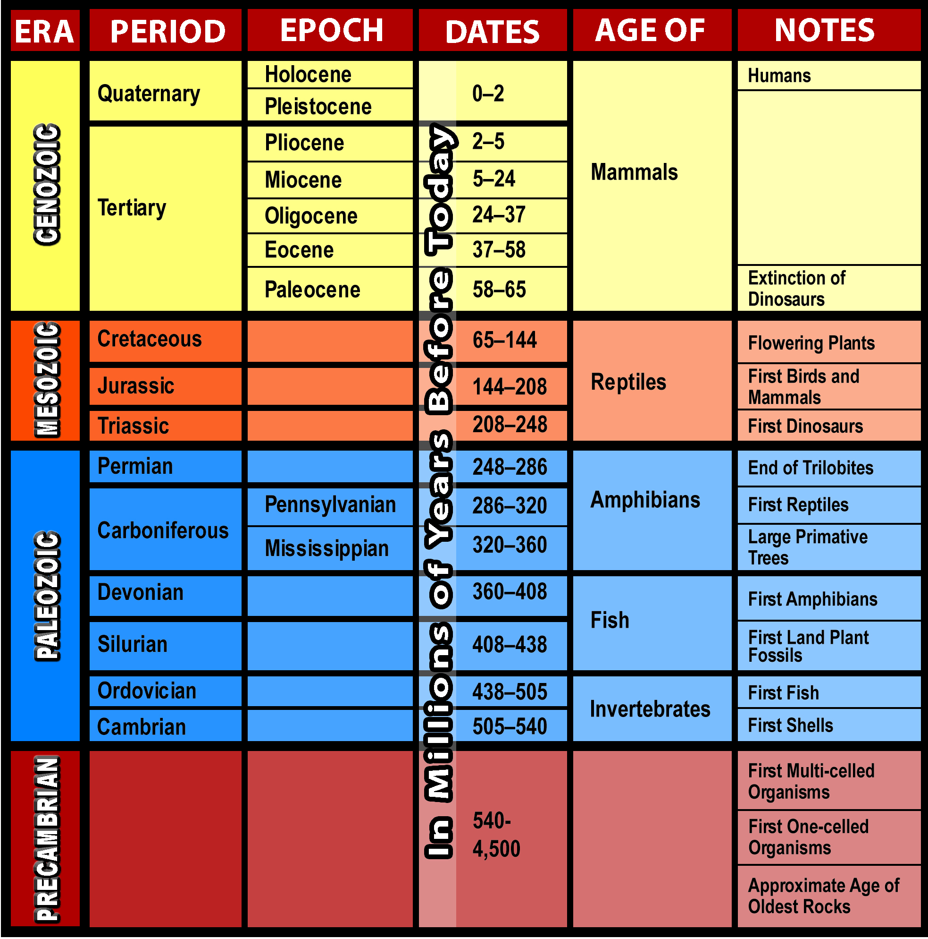
Unit 1 – Lesson 1 – Topic 2

Organizing Data 1 (continued)

Calcareous Shale Carbonate Claystone/Shale
Lignite Mudstone Sand & Gravel
Sandstone Siltstone Till

MESOZOIC ERA
CRETACEOUS PERIOD (65-144 million years before today)

CENOZOIC ERA
TERTIARY PERIOD (2-65 million years before today)
Paleocene Epoch (58-65 million years before today)

Eocene Epoch (37-58 million years before today)

Oligocene Epoch (24-37 million years before today)

Miocene Epoch (5-24 million years before today)

Pliocene Epoch (2-5 million years before today)

Unit 1 – Lesson 1 – Topic 2

Organizing Data 1 (continued)

QUATERNARY PERIOD (0-2 million years before today)
Pleistocene Epoch (0-2 million years before today)

Holocene Epoch (0-2 million years before today)

Concluding statement:

Unit 1 – Lesson 1 – Topic 2

Organizing Data 2

To access a photo/document/map, refer to the topic reading assignment or use the SEARCH feature to enter its name or number.

According to the Miriam-Webster online definition, a filmstrip is a strip of film bearing a sequence of images for projection as still pictures. The filmstrip was an effective educational tool used to give information to an audience before the electronic age came into being. It was first used in 1930, or less than 100 years ago.

Coal, petroleum, and natural gas were all created through a process of shallow seas covering and receding from an area several times over millions of years. From your reading and studying the cross sections for Images 6 and 8 (How Coal Formed 2 and How Petroleum Formed), create a filmstrip sequencing the process in illustrations to show how lignite coal and petroleum were formed in North Dakota. Share your filmstrip with other class members.


How Lignite Coal Was Formed

How Petroleum (Oil) Was Formed

Unit 1 – Lesson 1 – Topic 2

Debate/Discussion

At least three theories have been proposed to explain how Ice Age animals became extinct. From your reading, list reasons for the extinction based on each of the three theories mentioned. Then, compare your discussion points with those of a classmate. Together, come up with a concluding statement, and discuss whether or not some of the same concerns are relevant today.
Theory One

Theory Two
Theory Three

Concluding Statement:

