Unit 1 – Lesson 1 – Topic 1

TOPIC 1 – GEOLOGY and TIME

Topic Overview
Topic 1 highlights prehistoric geological events. It includes charts, terms, and explanations that will help you understand how ancient forces shaped the landscape and created the natural resources of present-day North Dakota.

Topic Objectives
- As a result of the study of Topic 1, you will be able to
  - Identify geologic terms.
  - Classify characteristics in the major divisions of the geologic time table.

ND Content Standards
- 8.1.2
- 8.5.1

Common Core Standards
- RH 4
- RH7
- WHST 2

Topic Activities
- Reading a Map
- Organizing Data

Unit 1 – Lesson 1 – Topic 1
Reading a Map 1

To access a photo/document/map, refer to the topic reading assignment or use the SEARCH feature to enter its name or number.

Geologic time is arranged in a particular sequence. From your reading and studying the Williston Basin Stratigraphy, Image 1, write characteristics for each of the Eras in the appropriate circle. In the box provided, state what your observations are for each Era.

Cenozoic Era
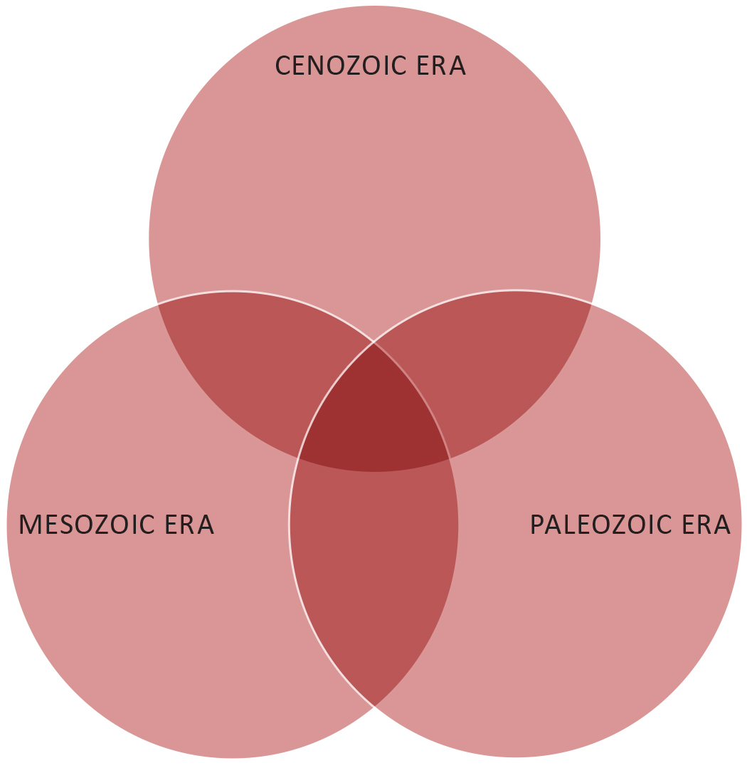
Paleozoic Era
Mesozoic Era

After studying these three Eras relating to the geologic time in North Dakota, list four (4) facts you learned about geologic time.

Unit 1 – Lesson 1 – Topic 1
Organizing Data

Create a deck of study cards for each of the following terms found in your reading. Write a definition, and draw an illustration on each card to clarify its meaning. Exchange with others to learn these geologic terms. Note: This activity could be a small group activity.

- BPE
- Core sample
- Coteau
- Dinosaurs
- Erratics
- Esker
- Extinction
- Formation
- Geologist
- Glacier
- Glacial till
- Iridium
- Lake Agassiz
- Lignite
- Mammals
- Moraine
- Paleontologist
- Sedimentary rock
- Strata
- Stratigraphy

Sample
Coteau – a French word meaning little hills.

An area where glaciers gouged out small lakes and ponds that do not drain into creeks or rivers.

