GENERAL ACTIVITIES
The general activities include an assortment of activities that may be used at the teacher’s or reader’s discretion for any topic. These activities are not topic sensitive and may be used to enhance any topic.
Books
- Several types of books can be created from the information gleaned from reading any of the topics or viewing any of the primary sources contained within each topic. Synthesizing this material by using one of the following types of books can assist the learner in recalling and making sense of what was read.
  - Topic Books – Using any topic, create a book that includes illustrations and definitions to share with a classmate, a small group, or the library.
  - Class Book – Using any topic, create an inclusive Glossary of terms learned. A visual representation of the term may be included for more clarity. For example, each student would be the expert for one topic within an overall lesson. When completed, each student’s topic Glossary would be shared with everyone.
    - A variation of a class book could include a small group of students taking charge of one topic within a lesson and creating a book that includes key points from the reading, along with illustrations and a glossary. These could be included with other small groups for one class book.
Brochures
- Create a brochure covers key points in any assigned reading of a topic.
Debate
- Complete a formal debate based on the following format. NOTE: Teachers may choose to use a more informal format by eliminating the stringent time frames and having students just take turns expressing views for their side. The objective of this activity is to have each side critically evaluate current evidence, examine personal convictions based on values and beliefs, and synthesize relevant information to provide detailed information so that others may make an informed decision.

  - Format – Two teams will be assigned. One team will create an affirmative presentation while the other team will be responsible for creating a negative or opposing presentation.

  - Debate Guidelines
    - Affirmative Plan (4 minutes) – This is your introduction. What will you be discussing and why? Get our attention.
    - Negative Rebuttal (2 minutes) – This is a direct rebuttal to the Affirmative. This team addresses only those issues identified in the Affirmative Team’s introduction.
    - Negative Plan (4 minutes) – This is your introduction. Get our attention. What will you be discussing and why?
    - Affirmative Rebuttal (2 minutes) – Direct rebuttal to the negative plan. This team addresses only those issues identified in the Negative’s team introduction.
    - 10 minute break for preparation/adjustment to argument.
    - Negative Argument (10 minutes) – This is the body of the speech. Lay it all out. Facts, stats, primary sources, argue your side. The Affirmative Team cannot interrupt during this argument.
    - Affirmative Cross Examination (8 minutes) – Ask the tough questions, demand answers, do anything and everything you can to counter the argument of the negative. The Negative Team does not ask questions back. Their role is to provide answers only.
    - Affirmative Arguments (10 minutes) – This is the body of the speech. Again, lay it all out . . . facts, stats, primary sources, argue your side. The Negative Team cannot interrupt during this argument.
    - Negative Cross Examination (8 minutes) – Ask the tough questions, demand answers, do anything and everything you can to counter the argument of the negative. The Affirmative Team does not ask questions back. Their role is to provide answers only.
    - 10 minute break to prepare for closing.
    - Affirmative Closing (5 minutes) – Use emotion for a big ending . . . you’ve seen the “TV lawyers” present their closing . . . do it here!
    - Negative Closing (5 minutes) – Same as Affirmative. Here’s your chance!

- Involvement by each participant is required.

Differentiated Demonstration of Knowledge
- Participants or small groups demonstrate their knowledge of a topic by using one of several formats listed below:
  - Radio Broadcast
  - Bulletin Board
  - Slide Presentation
  - Student-generated test
  - PowerPoint, iMovie, or other electronic presentation tool
  - News Report
  - Oral History
  - Television Report
  - Interview
  - Demonstration
  - Dramatization
  - Commercial
  - Poetry
  - Play
  - Role-play
  - Simulation
  - Skit
  - Song/Rap
  - TV Talk Show
  - Alliteration/Tongue Twister
  - Map
  - Mobile
  - Brochure
  - Crossword Puzzle
  - Fictitious Facebook Page
  - Scrapbook
  - Cartoon
  - Model/Diorama

Educational Links
- http://www.archives.gov/education/lessons/ – National Archives Teaching With Documents: Lesson Plans. On the right of the page are worksheet analyses for the following. These forms are completed online and cannot be saved but may be printed when completed.
  - Written Documents
  - Artifact
  - Cartoon
  - Map
  - Motion Picture
  - Photograph
  - Poster
  - Sound Recording
- http://docsteach.org/ - The National Archive Experience: Docs Teach. Click on to Create your own fun and engaging activities. This allows the user to create his/her own learning activity using primary resources for any of the following:
  - Finding a sequence
  - Focusing on details
  - Making connections
  - Mapping history
  - Seeing the big picture
  - Weighing the evidence
  - Interpreting data
- http://chroniclingamerica.loc.gov/ - Chronicling America is a program of the Library of Congress. It is easy to pick out North Dakota’s only newspaper, The Bismarck Tribune, in this collection and to check for topics between 1873 and 1922.
- http://ourdocuments.gov/ - This site lists the top 100 documents in U.S. history and could provide additional information.
- http://opd.mpls.k12.mn.us/ArtfulTools.html - Artful Tools are planning strategies and reflective tools that both teachers and students can use in their learning environment to assist in learning to think critically and to make meaning of their text or documents. The use of Artful Tools enhances the ability of teachers and students to pay closer attention to written, visual, and audio context. There are two types of Artful Tools:
- Critical Response is a structured process that allows responders to pay close attention to a particular piece of art, text, or performance. Through the guidance of a facilitator, a group responds to these five questions:
a. What do you notice? (Describe without judgment: "I notice...")
b. What does it remind you of? (What memory, experience, story, music, other work does this trigger? There are no wrong answers or associations.)
c. What emotions do you feel as you respond to this work? (Again, no wrong answers.)
d. What questions does it raise for you? ("I wonder...")
e. What meaning or understanding is intended or conveyed in this work?

- Descriptive Review is a reflective protocol grounded in pure description. No two people observing the same event or work will see the same thing. The shared perspective of a group helps the group itself or a presenter to become more aware of aspects of a work or lesson that might otherwise have escaped notice. Descriptive Review is premised on the notion that description without judgment leads to deeper understanding of a subject because it slows down the meaning-making and grounds it in close observation of what is actually perceivable.

  - What do you notice? Describe without judgment. ("I notice…")
  - What questions does this work, activity, or subject of inquiry raise for you? ("I wonder…")
  - What meaning or understanding is intended or conveyed in this work? Speculate on the meaning behind a work or what an artist, teacher, or presenter wants learners to understand.

- http://www.vtshome.org/what-is-vts - Visual Thinking Strategy (VTS) Method. In VTS discussions, teachers support student growth by facilitating discussions of carefully selected works of visual art. Teachers are asked to use three open-ended questions:
- What's going on in this picture?
- What do you see that makes you say that?
- What more can we find?

Facilitation Techniques:
- Paraphrase comments neutrally
- Point at the area being discussed
- Link and frame student comments

Students are asked to:
- Look carefully at works of art
- Talk about what they observe
- Back up their ideas with evidence
- Listen to and consider the views of others
- Discuss many possible interpretations

- http://weisman.jaws.umn.edu/artfulwriting/teachers.php - Artful Writing Perceive Activity. Before you read anything about the image, use your powers of observation to look slowly and closely at the image. Use the following questions as your guide for observing.

- What do you notice? (Imagine using all your senses.) What do you recognize?
- What feeling do you get from the image? Is there a mood?
- What does this image remind you of? What is going on? What other meanings could there be?
- What does the image make you wonder about? What more do you want to know?
Jigsaw Activity
- Divide students into small jigsaw groups (3-6) choosing one student as the leader.
- Divide the day’s lesson into 3-6 segments, depending on the size of the groups and the amount of material that needs to be covered.
- Assign each student to learn one segment, making sure students have direct access only to their segment.
- Give students time to read their segment at least twice and become familiar with it.
- Form temporary “expert groups” by having one student from each jigsaw group join other students assigned to the same segment to share their information learned.
- Bring the students back to their original jigsaw group, and have each student share his/her segment with the rest of the group.
- At the end of the session, have some form of assessment (e.g., quiz, discussion questions, written paper, graphic organizer, etc.) available to check for understanding. This shows students that individual accountability for learning all the information, although presented as a group, is the objective of the activity.

North Dakota Map Outlines
| Page 7 |
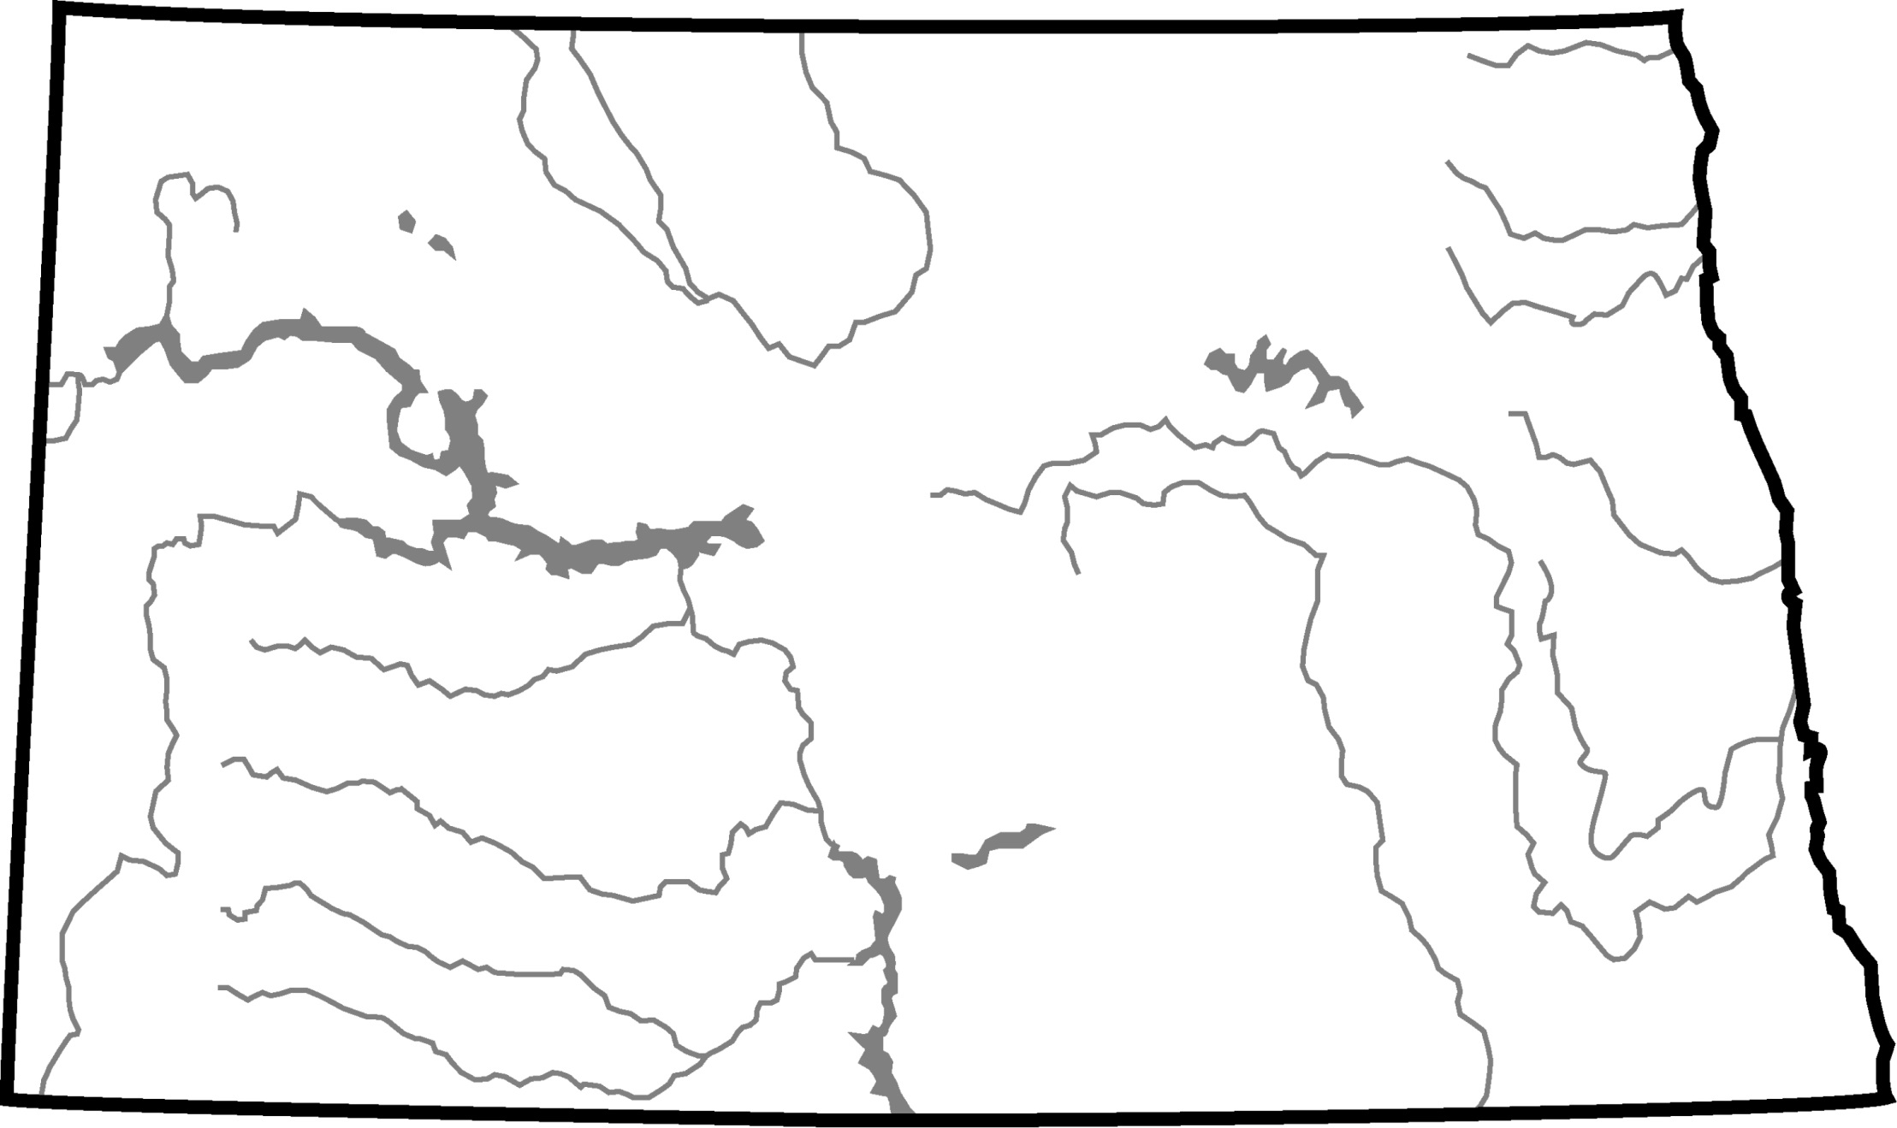
| Page 8 |
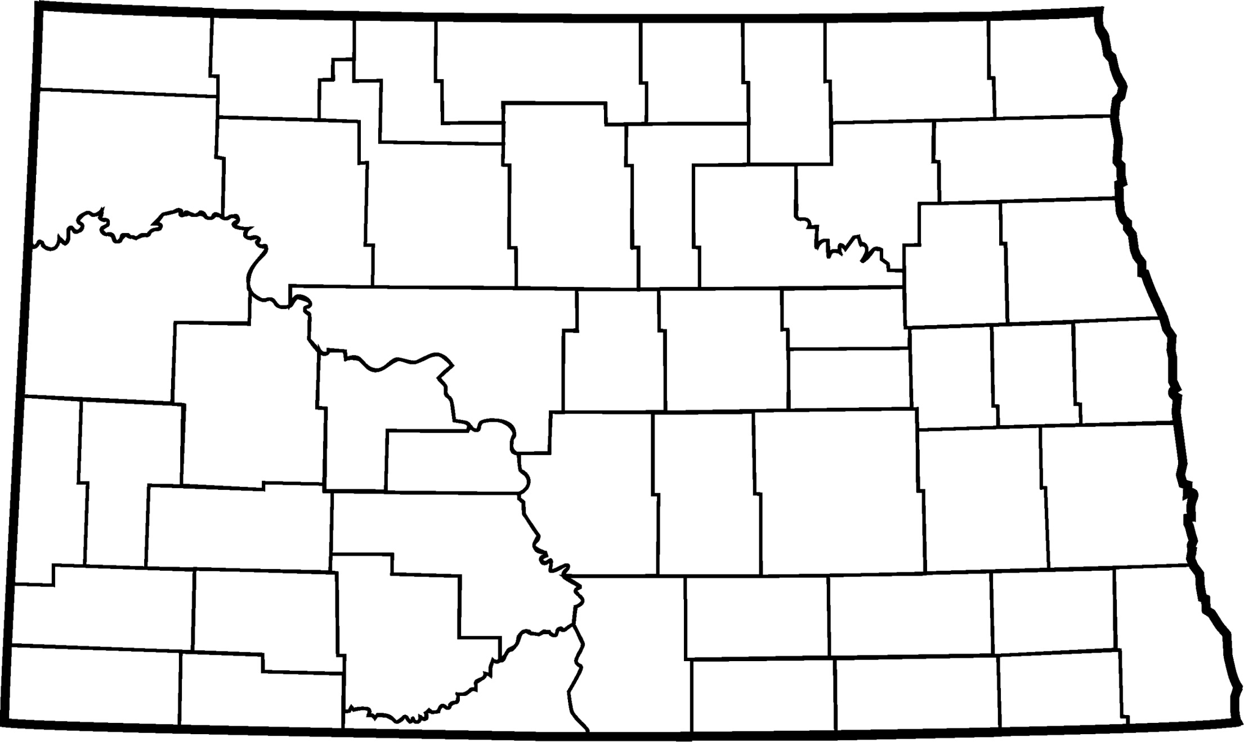
| Page 9 |
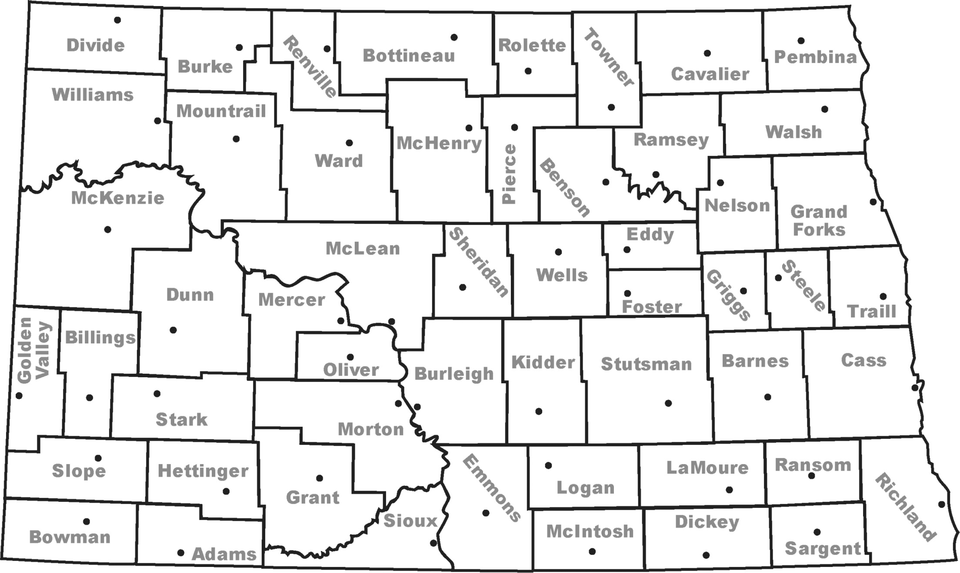
| Page 10 |
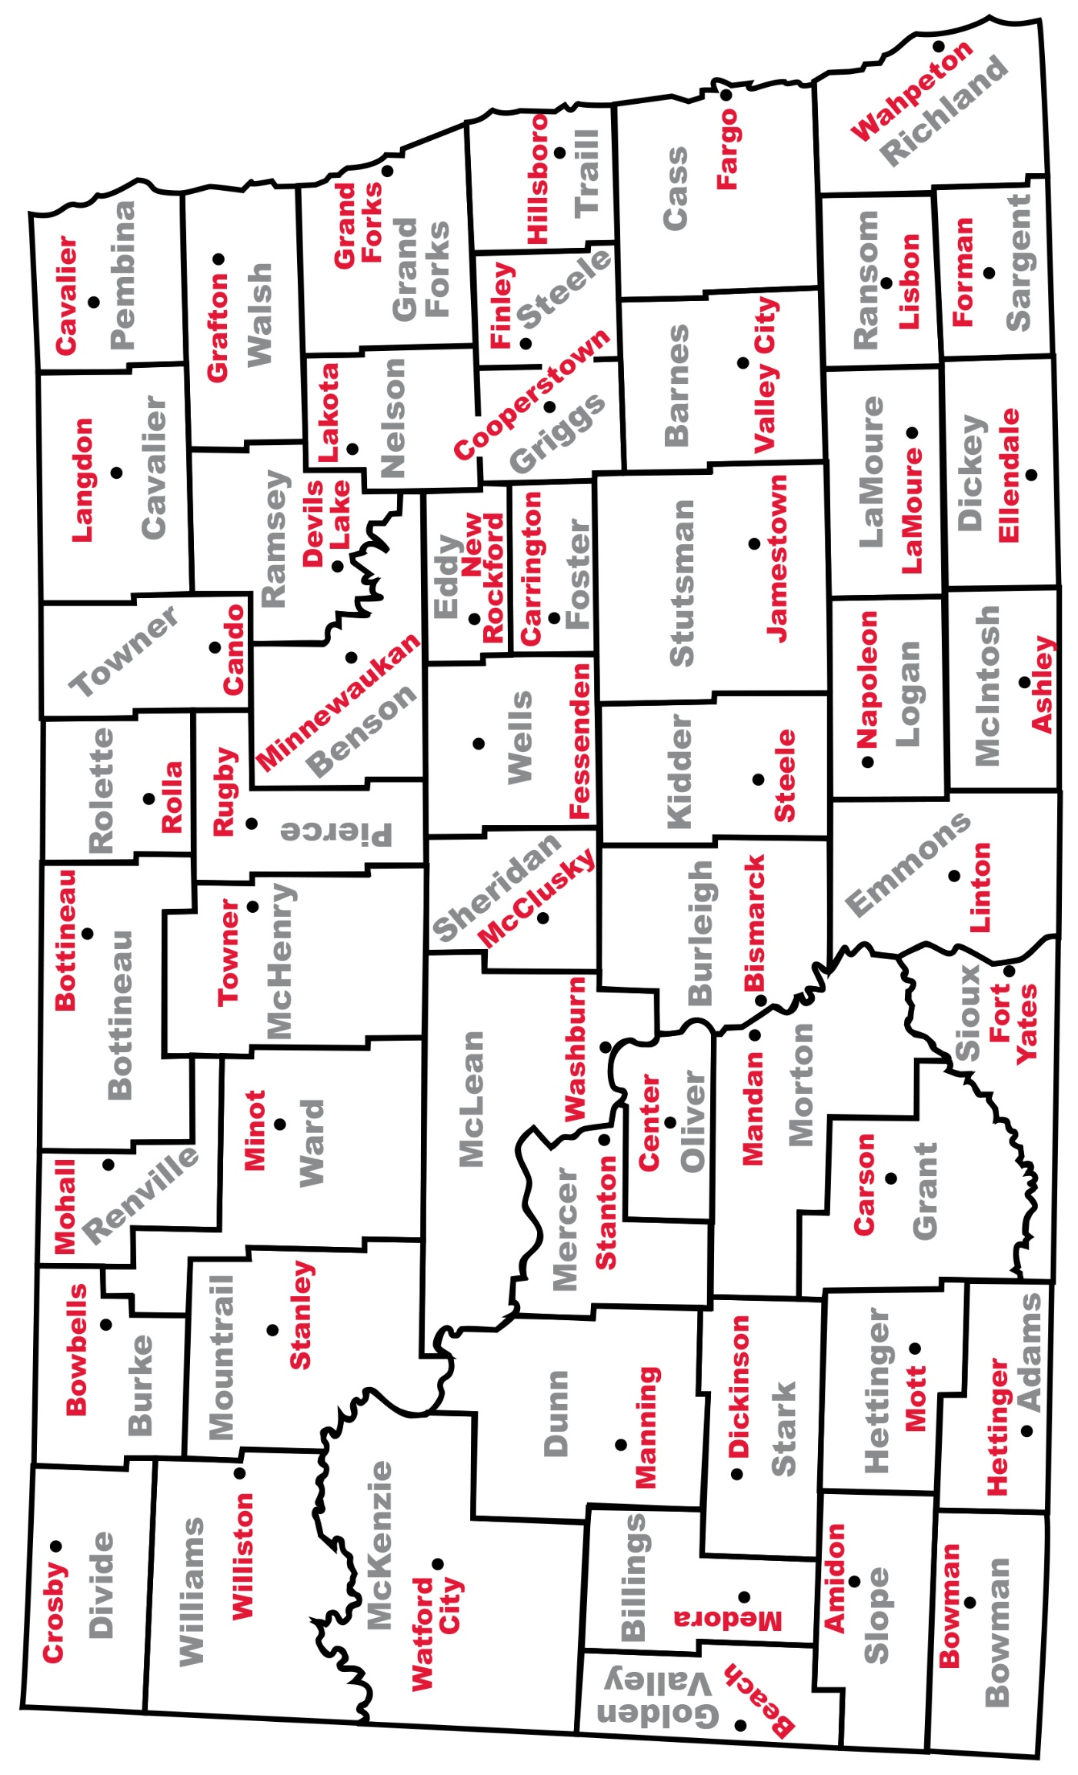
| Page 11 |

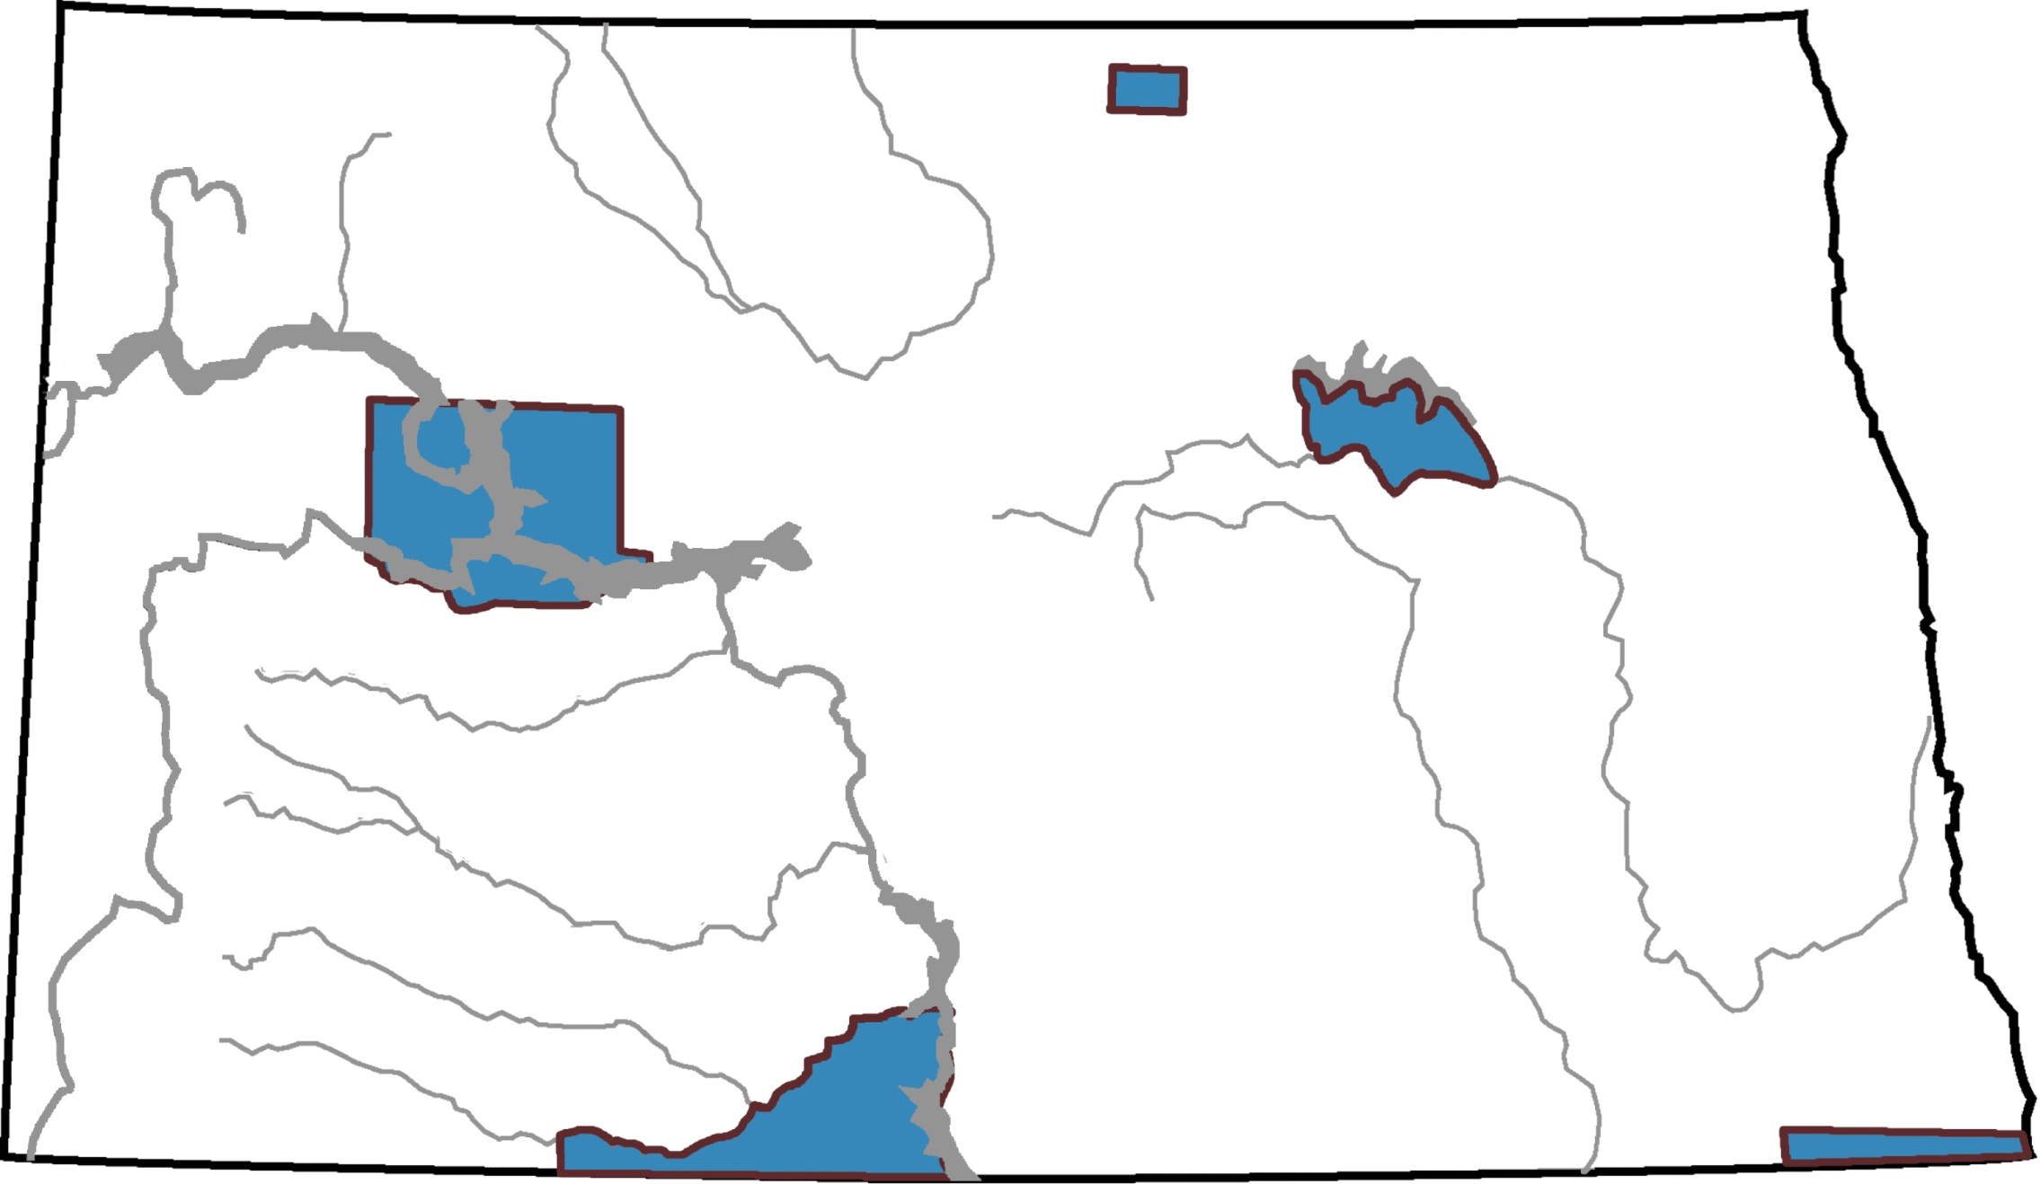
| Page 12 |
Poetry
- Create poetry from reading and studying any topic using one of the following styles:
  - Couplets (two-line stanza that rhymes).
  - Triplets (three-line poems).
    - Patterns include ABB (two of the lines rhyme), AAA (all three lines rhyme), ABC (no lines rhyme). A triplet may be written in the shape of a triangle and can be read by starting at any corner.
  - Haiku
    - Line 1 – five syllables
    - Line 2 – seven syllables
    - Line 3 – five syllables
  - Cinquain
    - Line 1 – one word (title)
    - Line 2 – two words (describe the title)
    - Line 3 – three words (describe an action)
    - Line 4 – four words (describe a feeling)
    - Line 5 – one word (refer back to the title)
  - Diamanté (Diamond)
    - Line 1 – one noun (subject #1)
    - Line 2 – two adjectives (describing subject #1)
    - Line 3 – three participles (ending in –ing, telling the subject)
    - Line 4 – four nouns (first two related to subject #1, second two related to subject #2)
    - Line 5 – three participles (about subject #2)
    - Line 6 – two adjectives (describing subject #2)
    - Line 7 – one noun (subject #2)
  - ABC Poetry (Start with A and go through the alphabet writing a word for each letter. This could be completed with one topic or one lesson.
  - Acrostic Poems (The first letters of the line spell out a word/sentence that relates to the topic.)
  - Lanterns (Japanese poem that is written in the shape of a Japanese lantern.)
    - Line 1 – one syllable
    - Line 2 – two syllables
    - Line 3 – three syllables
    - Line 4 – four syllables
    - Line 5 – one syllable
Think, Pair, Share Activity
- After reading, studying, or discussing a particular topic, have participants think about the topic by themselves. Working in pairs, have them share their ideas and thoughts with each other. This enables the facilitator to observe what the participant’s knowledge is regarding the topic being studied. Then, have pairs of participants share with other small groups or with the entire group.

Thinking Like A Historian (Mandell, Nikki and Malone, Bobbie. Wisconsin Historical Society Press)
What Questions Do We Ask of the Past?
Cause and Effect
- What were the causes of past events?
- What were the effects?
  - Who or what made change happen?
  - Who supported change?
  - Who did not support change?
  - Which effects were intended?
  - Which effects were accidental?
  - How did events affect people’s lives, community, and the world?
Change and Continuity
- What has changed?
- What has remained the same?
  - Who has benefited from this change?
  - Who has not benefited? Why?
Turning Points
- How did past decisions or actions affect future choices?
  - How did decisions or actions narrow or eliminate choices for people?
  - How did decisions or actions significantly transform people’s lives?

Using the Past
- How does the past help us make sense of the present?
  - How is the past similar to the present?
  - How is the past different from the present?
  - What can we learn from the past?
Through Their Eyes
- How did people in the past view their world?
  - How did their worldview affect their choices and actions?
  - What values, skills, and forms of knowledge did people need to succeed?

